GEOtest, a.s. tel.: 548 125 111
Šmahova 1244/112, 627 00 Brno fax: 545 217 979
ID No.: 46344942 Tax ID No.: CZ46344942 e-mail: info@geotest.cz
Geological and remediation work, geotechnical and hydrogeological investigation

Number and title of contract: 16 0327 Ethiopia – holistic management Arba Minch
Client: Czech Development Agency, Nerudova 3, 118 50 Praha 1
Mendel University in Brno, Zemědělská 1665/1, 613 00 Brno

ANNEX 1

ACCESS TO THE FREELY AVAILABLE DATA SOURCES

Project manager: Mgr. Jan Oprchal, Production Manager, GIS Specialist
Prepared by: Mgr. Jiří Hladík, GIS Specialist
Bc. Cristina Medina Solano, GIS Specialist
Approved by: Ing. Jaromír Novák, Production Manager

___________________________________
RNDr. Lubomír Klímek, MBA
Managing Director

Brno, February 2018

Websites directory
The main recommended web data sources where we can obtain the different satellites images for free, in different formats (satellite images, DEM, orthophotos...) are following:

- LP DAAC USGS (Land Processes Distributed Active Archive Centre): https://lpdaac.usgs.gov/data_access
- Earth Explorer (USGS EarthExplorer EE) http://earthexplorer.usgs.gov/
- GloVis (USGS Global Visualization Viewer) http://glovis.usgs.gov/
- GDEx USGS (Global Data Explorer) http://gdex.cr.usgs.gov/gdex/ MDE ASTER SRTM (Shuttle Radar Topography Mission).
- ASTER get data (Jet Propulsion Laboratory, NASA): http://asterweb.jpl.nasa.gov/
- EO-1 ALI / Hyperion: http://eo1.usgs.gov/
- MODIS: http://modis.gsfc.nasa.gov/data
- MODIS cryosphere: http://nsidc.org/data/modis/index.html
- MODIS Web Mapping Service (WMS): http://neo.sci.gsfc.nasa.gov/about/wms.php

Landsat data
The main products that we have used for the study are the Landsat 5 and 8 satellite images and DEM from Aster.
The Landsat 5 and 8 have the following main characteristics:

Parameters | LANDSAT-5
Orbit altitude | 705 km
Spectral bands | BANDS | WAVELENGTH(NM) | GSD (M)
 | MSS
 | 4-GREEN | 500-600 | 57X79
 | 5-RED | 600-700 | 57X79
 | 6-NEAR INFRARED | 700-800 | 57X79
 | 7-INFRARED | 800-1100 | 57X79
 | TM
 | 1-BLUE | 450-520 | 30
 | 2-GREEN | 520-600 | 30
 | 3-RED | 630-690 | 30
 | 4-INFRARED | 760-900 | 30
 | 5-INFRARED | 1550-1750 | 30
 | 6-TERMAL INFRARED | 10400-12500 | 120
 | 7-MID INFRARED | 2080-1350 | 30
WIDTH | 185 km
GSD | 30-120
WORKING PERIOD | 1984-2013
FREQUENCY | 16 days

Landsat 8:
Parameters | LANDSAT-8
Orbit altitude | 705 km
Spectral bands | BANDS | WAVELENGTH(NM) | GSD (M)
 | 1-COASTAL AEROSOL | 300 | 30
 | 2-BLUE | 450-510 | 30
 | 3-GREEN | 530-590 | 30
 | 4-RED | 640-670 | 30
 | 5-INFRARED | 850-880 | 30
 | 6-SWIR 1 | 1570-1650 | 30
 | 7-SWIR 2 | 2110-2290 | 30
 | 8-PANCHROMATIC | 500-680 | 15
 | 9-CIRRUS | 1360-1380 | 30
 | 10-TERMAL INFRARED | 10600-11190 | 100 (30)
 | 11-TERMAL INFRARED 2 | 11500-12510 | 100 (30)
WIDTH | 185 km
GSD | 15-30
WORKING PERIOD | 2013-2018 (has supplies until 2023)
FREQUENCY | 16 days

As we can observe, the Landsat 8 images have more amplitude of bands including new ones that were not in Landsat 5, for example “Coastal Blue” and SWIR. But the reason we took images from Landsat 5 satellite is its working period. We needed the oldest images possible for the complete study. The oldest ones were the Landsat 5 images from 1985 (checking also the availability of the images, is that to say, the presence of clouds over the study area) and, from 2015, we took the Landsat 8 image because the Landsat 5 was not operable and Landsat 8 was already on orbit.
In the following pages, there is a summary of how to obtain the satellite images in Earth Explorer website:
The main source used in this study is “Earth Explorer” from the USGS. Here there are the main steps shown to explore and download the satellite images:
We go to the main page of Earth Explorer:
Click on “Register” to create a new user and follow the instructions, this website is free and the registration process is easy. Once created the new user, click on “Login” and insert your username and password.

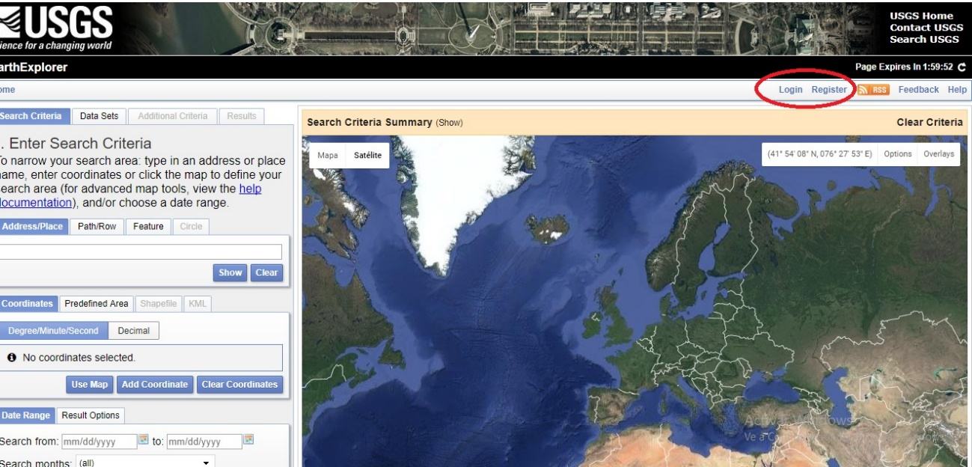

On the left side of the screen, there is a search box, we can search the images inserting the name and the spatial coordinates.

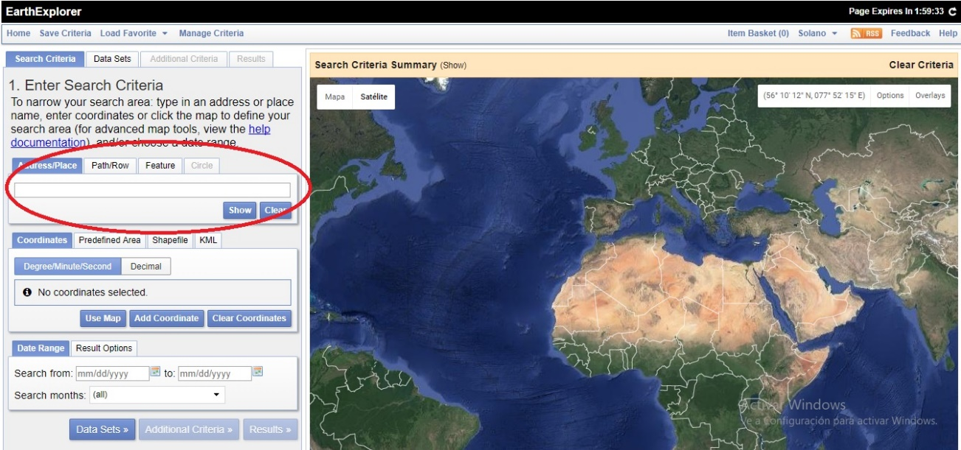

Write down the place. Then, into the box below, insert the date or the period of time in which your image was generated.

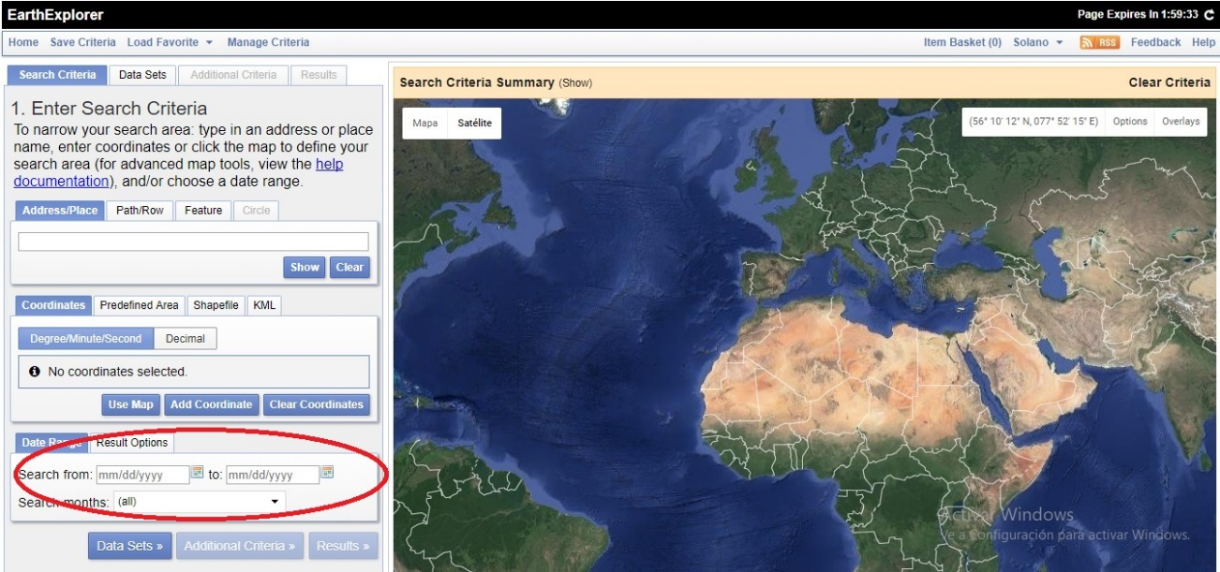

Once we inserted the name, some general information appears as shown in the picture below:
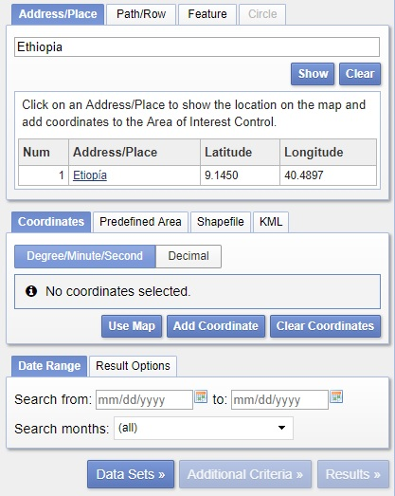

Once defined the area of the study, we click on “Data Sets” and select from which satellite we need the images. In this example, we will look for Landsat 5. Click on “Results”:
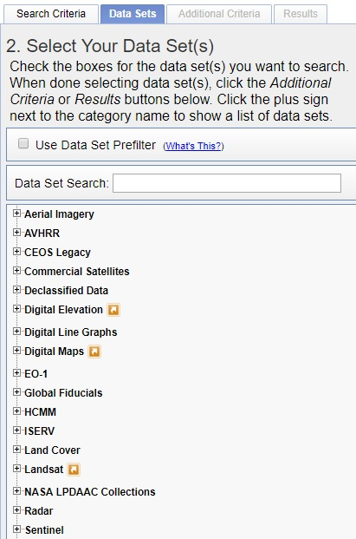
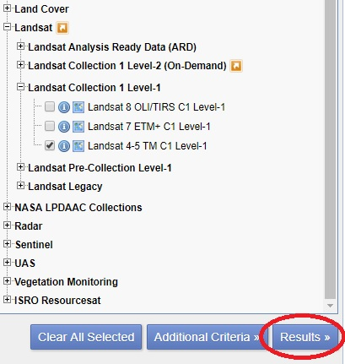

The results will appear in the box showing the date of the image and its path and row. Select the exact data and explore the images clicking on the image icon next to the footprint, there you can observe a preview of the image without downloading it.

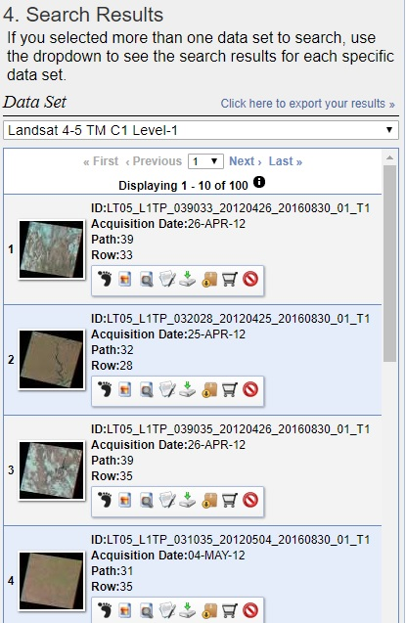
Once decided what image or images we want to download, click on the icon marked in red to access to the download process:
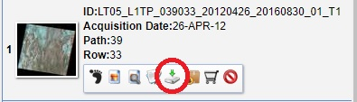
And finally, the following window will appear, asking us what file we want to download. We click on the last one (GeoTIFF format) if we want to download the full file with all the bands included, and finally, we get the satellite image.
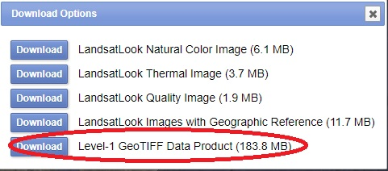

ASTER data
The second important product, we have used in the whole study, is the Aster DEM, whose main characteristics are:
Aster in an optical images sensor with high radiometric and geometric resolution, transported by the TERRA satellite from NASA. Its activity starting date was 18 December 1999. Aster has a strip of 60 km width and has two main fundamental characteristics: High spatial resolution and wide spectral range.
Bands | Number of bands | Amplitude
VNIR | 3 | 0,52-0,86 µm
SWIR | 6 | 1,6-2,43 µm
TIR | 5 | 8,125-11,65 µm

How to obtain ASTER data:

We go to the website: http://gdex.cr.usgs.gov/gdex/
The following image will appear (picture A). First, we have to register a new user. Click on the icon surrounded by a red circle, “Log in” and then create a new user, then log in with the new credentials.
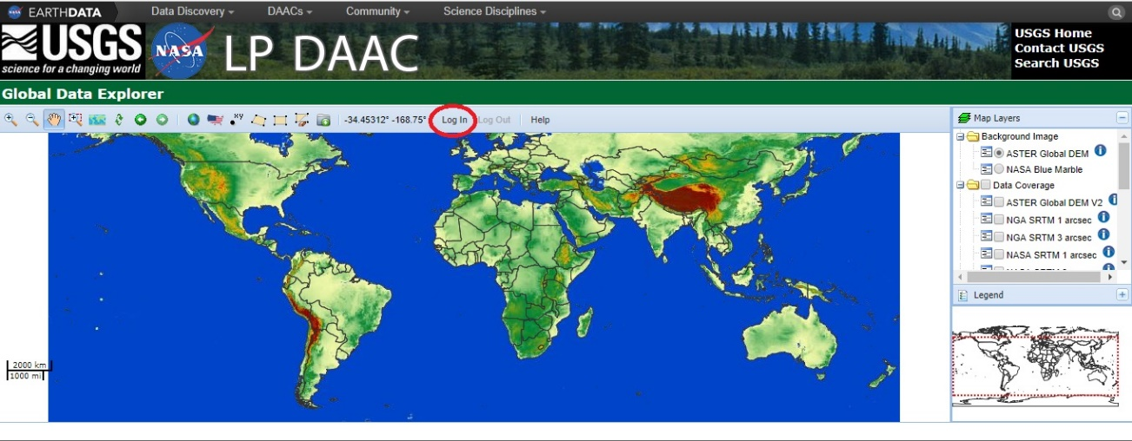
Picture A: Main screen of Aster website.

The following step is to localize the area from which we need the data. There are many ways to access the data - we can insert the coordinates, we can select by rectangle over the global map, but the easier way to localize the area is selecting directly the country and the district or province from the box that appears clicking on the icon surrounded by a red circle:
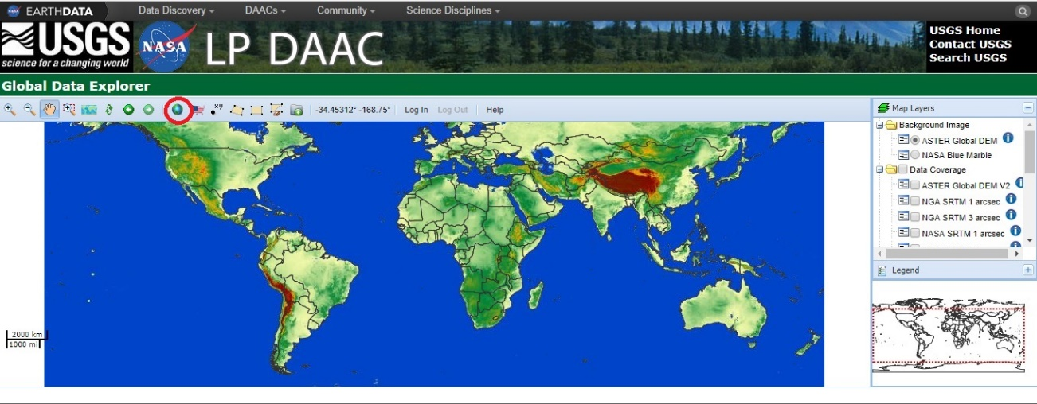
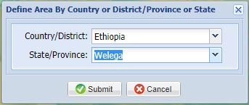

Automatically after clicking on “Submit”, the map will zoom to the study area.
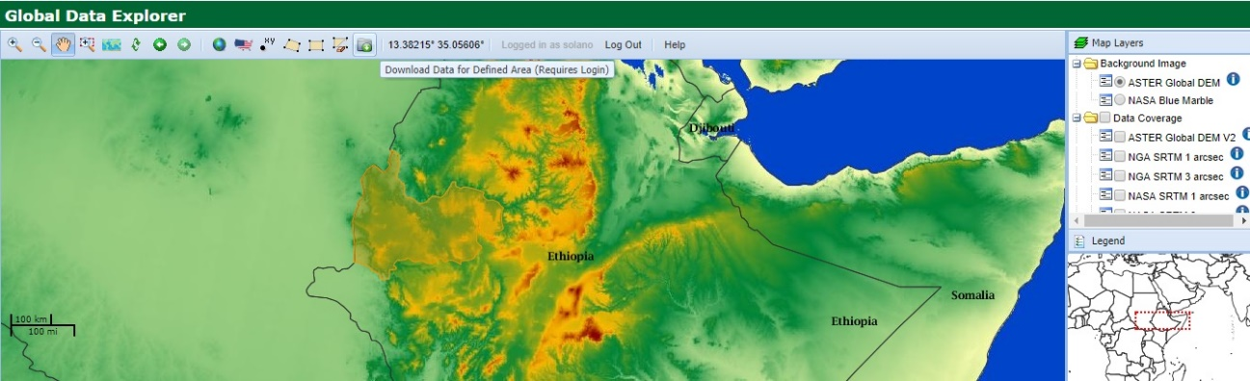

Once selected the study area, click on “Submit” and the following window will appear. In this box, you can select the type of product, the format and the option of downloading it in .zip file. Once filled the whole box, click on “Submit”.
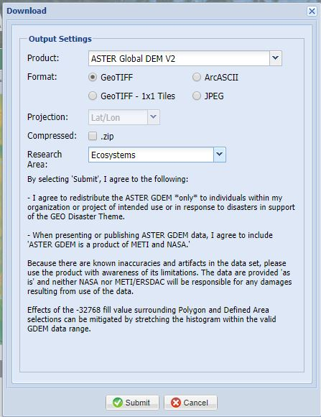
After clicking on “Submit”, the following window will appear, with a preview of the data, we can access also to the metadata there. Clicking on “Download” the download will start automatically, and finally, our data will be ready to use.
