GEOtest, a.s. tel.: 548 125 111
Šmahova 1244/112, 627 00 Brno fax: 545 217 979
ID No.: 46344942 Tax ID No.: CZ46344942 e-mail: info@geotest.cz
Geological and remediation work, geotechnical and hydrogeological investigation

Number and title of contract: 16 0327 Ethiopia – holistic management Arba Minch
Client: Czech Development Agency, Nerudova 3, 118 50 Praha 1
Mendel University in Brno, Zemědělská 1665/1, 613 00 Brno

ANNEX 2
GUIDEBOOK ABOUT THE PROCEDURE OF GENERATING THE SOIL EROSION RISK MAPS WITH GIS SYSTEMS

Project manager: Mgr. Jan Oprchal, Production Manager, GIS Specialist
Prepared by: Mgr. Jiří Hladík, GIS Specialist
Bc. Cristina Medina Solano, GIS Specialist
Approved by: Ing. Jaromír Novák, Production Manager

___________________________________
RNDr. Lubomír Klímek, MBA
Managing Director

Brno, February 2018

Following text presents whole procedure to gain maps of RUSLE equation and multitemporal analysis comparison maps for selected area across the riverbasins of Kurpayo, Hare and Baso. Presented procedure can be reused in any other place on the Earth.

First of all, the main structure in which the study will be based is in the RUSLE equation (Revised Universal Soil Loss Equation):

A=R*K*LS*C*P
Where:
A = Annual mean soil loss [t/ha/year]
R = Rainfall erosivity factor [MJ/ha*mm/hr]
K = Soil erodibility factor [t/ha.MJ*ha/mm*hr]
LS = Topographic factor (length-slope). Dimensionless
C = Cover factor (cubierta vegetal), Dimensionless
P = Conservation practises factor (conservation of the soil structure), dimensionless
With GIS systems we will generate one raster file of each factor using the raster calculator for to calculate of the RUSLE.
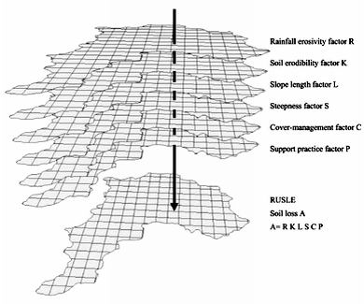

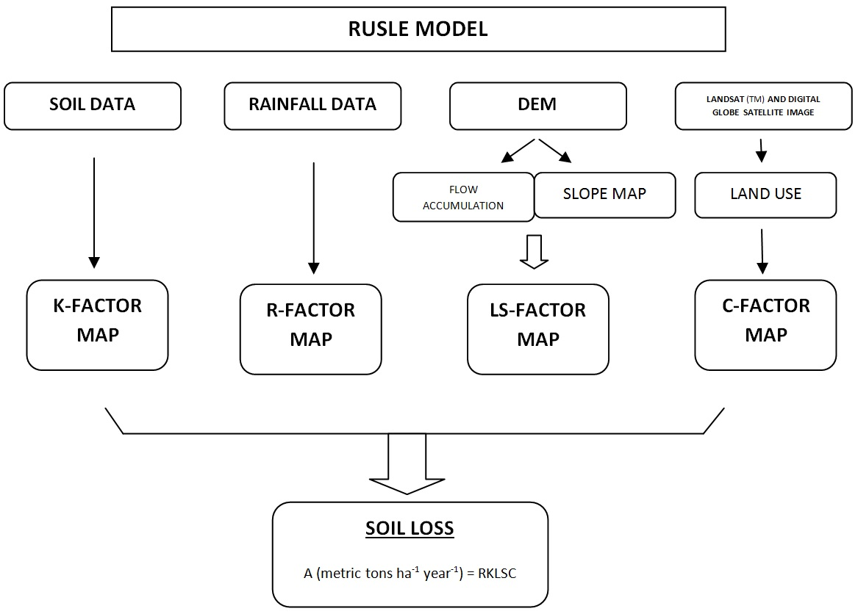

The picture above shows which kind of data source gives us each factor, is that to say the precedence of each factor.

To begin the study, we generate a shapefile with borders of the study area to have this shape as a reference to generate all the factors with the same border shape.
With this border shape, we cut the DEM file we need for to work. After having our DEM file, we will treat it to improve the resolution and imperfections following the route:

ArcToolbox/Spatial Analysis Tools/ Hydrology/Fill
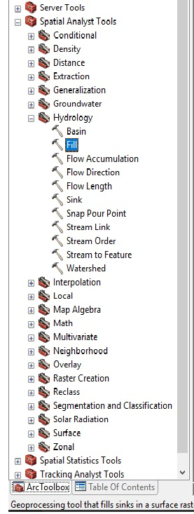

To generate our Slope map:
ArcToolbox/Spatial Analysis Tools/Surface/Slope
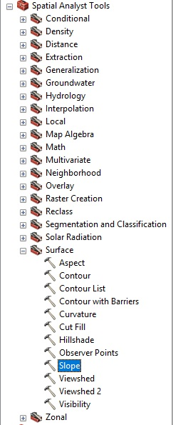

In this way, we generate the Slope Map in degrees. We will name this file as “Slope”.

We will generate also two different variables: Flow direction and Flow accumulation. The flow direction indicates the direction of the water flow in our study area, the flow accumulation indicates places where big masses of water can be accumulated.
For this, we use our DEM, and in the menu “Spatial Analysis Tool”/”Hydrology”, we select “Flow direction”, and we save the file. In the same menu, we realize the same procedure but we will use the submenu called “Flow accumulation” to obtain this second variable.
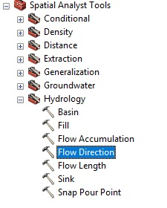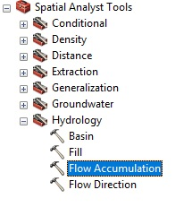
After we generate the slope, we can start to generate the different factors that conform our goal in this study.

LS-FACTOR
This factor combines two different parameters: the length of the slope (L) and its inclination angle (S). LS represents the soil loss relation that is awaited per unit area in a determined slope in relation to the corresponding loss in a 9% slope and 22,13 meters in length. This factor is one of the most difficult to calculate when USLE has not applied a plot scale, where the terrains are uniform as much in slope grade as in flow length (A.G. Barrios, 2000).
L-Factor: Where λ is the length of the slope, M is the exponent of the slope length and β is the angle of the slope. The slope length is defined as the horizontal distance from where the superficial flow is originated to the point where the deposition begins or where the runoff flows into a defined channel (Foster et al., 1977).
The LS-factor is calculated from the DEM (Digital Elevation Model) of the area and Hydrology, Slope and Map Algebra geoprocessing tools. In order to calculate the L-factor, it is necessary to calculate the M-factor beforehand. The M-factor is the constant that depends on the slope gradient (eq 2), for its a calculation is used in the eq 3, the F-factor that counts with the slope in degrees.
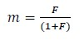
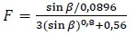
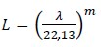

Once obtained the previous factors, the L-factor is calculated through the eq 4, which contains the drainage contributing area (Desmet & Govers, 1996), adapted for GIS systems.
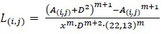

Where A(i, j) [m] is the unitary contributing area in the one-pixel entrance (cell), D is the pixel size and x is the correction factor of the shape.

The S-factor: The β angle is taken as the medium angle in all of the subgrids in the direction of higher slope (McCOOL et al., 1987, 1989)
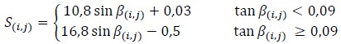

It is necessary to transform the units of the angle to radians (1 sexagesimal grade = 0,01745 radians), to multiply it with the rest of the components of the RUSLE equation. In the final equation, this transformation is added.
Having a theoretical idea of the LS-Factor, we will start calculating the L-Factor, for this task we have to calculate the F and M-factor first, both needed to get the L-Factor.
Starting with the F-factor we follow the following route:

Go to ArcToolbox/Map Algebra/ Raster Calculator
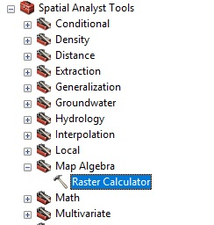

Once there, we introduce the following characters into the raster calculator that are corresponding to the F equation.
Notice that we have to enter each variable with the name that we have assigned to each raster, for example, I called “Slopedeg” to the slope map I generate before.

((Sin("slopedeg" * 0.01745) / 0.0896) / (3 * Power(Sin("slopedeg" * 0.01745),0.8) + 0.56))

We save the file with the name of F-factor.
Once we have F-factor, we can calculate M-factor. That value will be used to calculate the L-factor.

To calculate the M-factor, we apply the following equation:
"Factor_F" / (1 + "Factor_F")

Save the file with the name of M-factor.
We now have the “m” and “F” factor and the following step is to calculate the “L” factor whose equation is shown below:

As indicated before, A (i, j) [m] is the unitary contributing area in the one-pixel entrance (cell), D is the pixel size and x is the correction factor of the shape, so, we will introduce this equation to the Raster Calculator adapted to its terms:

(Power (("FlowAcu" + 625),("factor_m" + 1)) - Power("FlowAcu",("factor_m" + 1))) / (Power(25,("factor_m" + 2)) * Power(22.13,"factor_m"))

Save the file with the name of L-factor.
Having both L and S-factor we multiply it in Raster Calculator. And finally, we have the LS-factor map generated:
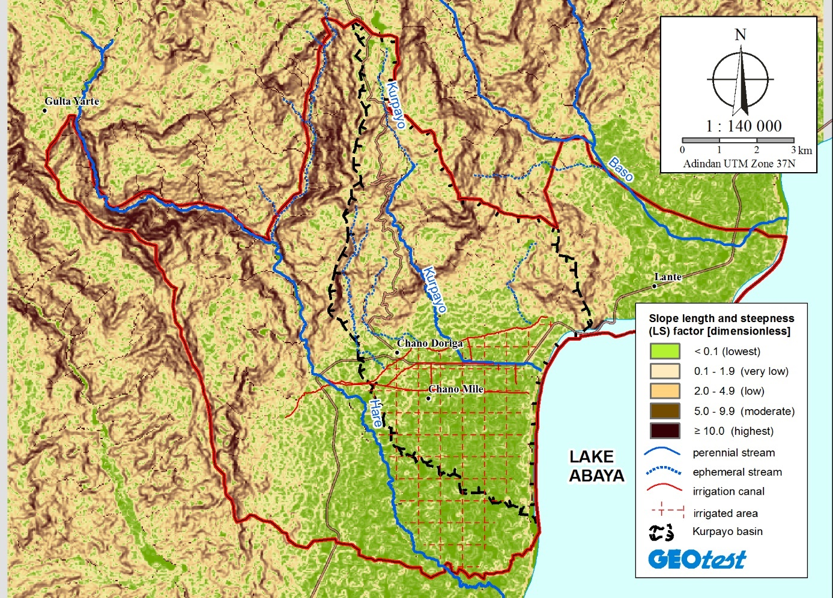
Fig. 1: LS-factor

R-FACTOR
The R-factor quantifies the rainfall impact associated with the precipitation amount in a determined area. The erosivity factor was calculated according to the equation given by Hurni (1985) for Ethiopian conditions based on the mean annual rainfall data (P):
R = -8,12 + (0,562 x P)

To complete this equation, we need the mean annual rainfall data (P) in mm in a given place. So, in the first place, it is necessary to generate a shapefile of the area containing all the meteorological stations with corresponding mean annual rainfall data.

1st step: Take the coordinates of each meteorological station.
2nd step: Generate a shapefile, the type of this shapefile has to be point shape. It can be a copy of the border shape, to have all the necessary area included.
3rd step: Create the points with the coordinates of the stations.
Once we have generated the shapefile, we have to add the annual rainfall data (P) to the attributes table in each point, also with the name of the station and the coordinates. In this way, we can have the information easily and if we want to generate a map with the data, we need to have this data included in our shapefile.
After this, we have to transform our shapefile into raster file with the P value, in order to use the raster calculator with our R equation.
After converting the file, we use the raster calculator and input the R equation.
R = -8,12 + (0,562 x P)
In the place of the letter “P” we must insert the raster file with the mean annual data.
We will obtain the R value but only in the specified points. To obtain continuous data in the whole area of our raster file (area of the study), we will interpolate the data using IDW method.

Go to:
Spatial analysis tool/interpolation/IDW
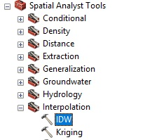

And finally, our R-Factor map is generated:
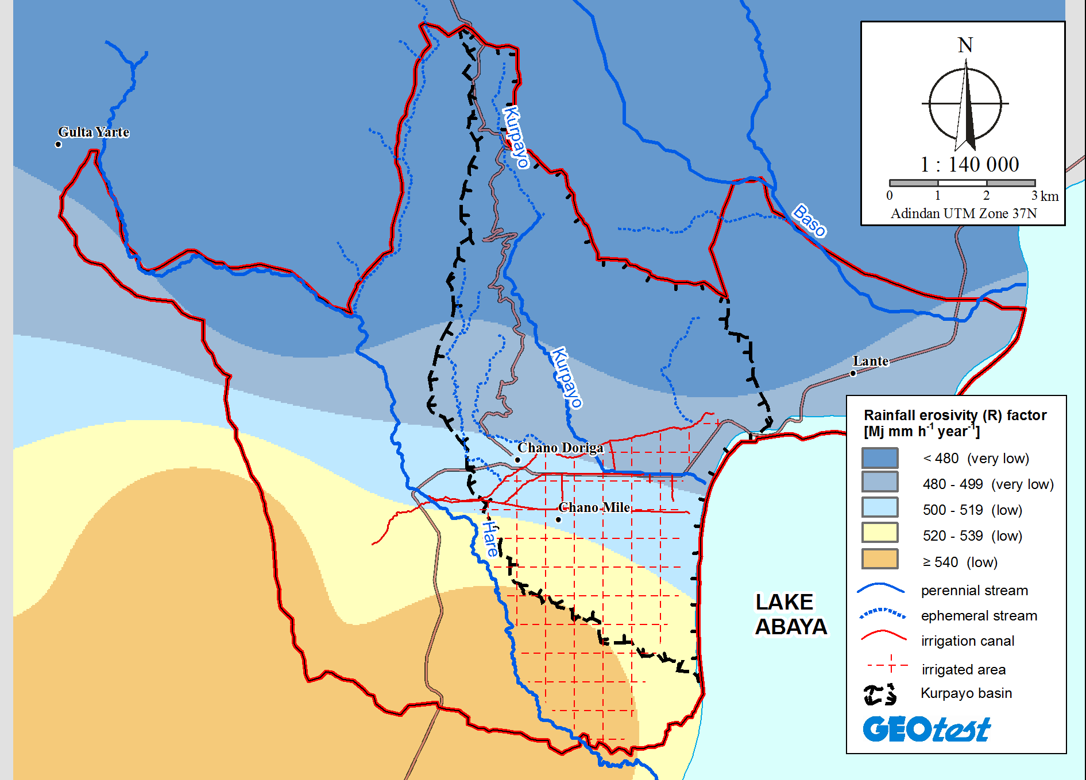
Fig. 2: R-factor

K-FACTOR
The K-factor expresses the resistance of the soil particles to the detaching and transporting power of the rainfall. The K-factor is empirically determined for a particular soil type and reflects the physical and chemical properties of the soil, which contribute to its potential erodibility (Animka, 2013).
Hurni (1985) and Hellden (1987) recommended classifying the K-value according to its observable characteristics like the colour. Hence, the soil types in this study were reclassified based on the soil colour class given by Hurni (1985) and Hellden (1987).

Soil colour | Name/class | Estimated k-value  (metric tons ha⁻¹ Mj⁻¹ mm⁻¹)
Black | Andosols, Vertisols…etc | 0,15
Brown | Cambisols, Regosols, Luvisols, Phaeozems…etc | 0,20
Red | Lixisols, Nitosols, Alisols… | 0,25
Yellow | Fluvisols, Xerosols….etc | 0,3

To generate our K-factor map, we have two options for obtaining it: the first one is to have our own data taken from the field study. Another one is taking the information from different sources, like books, maps or internet.
Taking the data yourself in the study area is possible with GPS systems, taking samples at different points and then uploading it to the computer and working with GIS software.
The second way offers different ways of getting information, but if this is the chosen way, it is recommended to verify and contrast the information to be sure that we are working with true data, or at least, the most possibly real ones.
Once we have our soil map of the area, we have to include another column with the data referring to K value into the attribute table. For this task, we have to take into account the classification method that different authors have realized, for example, in the table above, we can see different keys of classification depending on the soil colour. Once found our reference key, it is time to add the K-value for each type of soil into the attribute table.
With our shapefile of soil type generated, we procedure to convert the shapefile into raster file with the K-value as a reference. Thus, we will have our k-factor raster file ready.
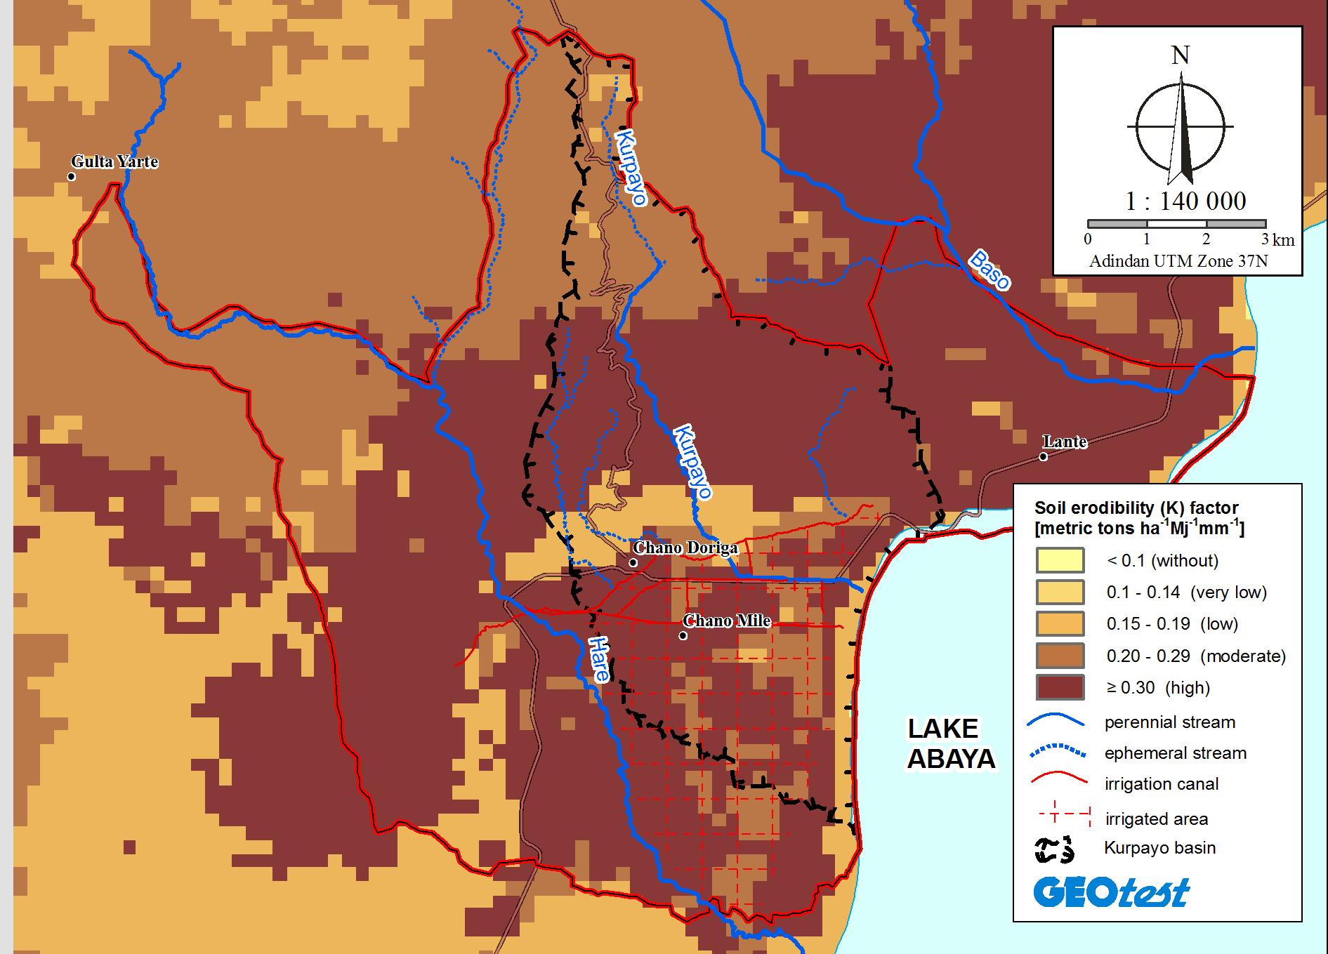
Fig. 3: K-factor

C-FACTOR
The C-Factor represents the quantity of soil loss determined that depends on the specific vegetation situated in the area. It is the factor that can change most easily but for this reason, it is the factor most often considered for developing an effective conservation plan. The C-factor is dimensionless.
To calculate the C-factor, it is necessary to generate a land use map in which different types of vegetation appear. Later, each soil use will be reclassified according to the C value given by different studies.

Land use/Land Cover | C-factor | References
Water body | 0 | Erdogan et al (2006)
Cultivated | 0,1 | Hurni (1985)
Forest | 0,01 | Hurni (1985)
Shrub | 0,014 | Wischmeier & Smith (1978)
Grazing land | 0,05 | Hurni (1985), Yihenew (2013)

Again, we have here two options for obtaining the information about the vegetation cover in a determined area. One of these options is to find the vegetation cover map in a source that has generated it previously, or to generate a vegetation classification map through satellite images and GIS software.
In this case, we have generated our own vegetation map. The procedure of it is explained in the following paragraphs, to present an idea of generating it.
To obtain a land use map of the area, a supervised classification from the satellite image Landsat 8 from the year 2015 has been generated in ENVI environment, in reference to the DigitalGlobe satellite image from 2016. The result is a raster file with the C value of each class of land use in the study area.
This is a general explanation of how to make a vegetation classification map.
The process of vegetation classification consists of two first stages, the first one, a shape with diverse polygons of each different vegetation classes is generated in ArcGIS environment, which is called “training”, the second stage consists in verifying the “training” stage by generating another shape called “verification” which includes much more polygon samples of each class. Continually, by using ENVI environment the whole area of the satellite image is classified in reference to the shape called “verification”.
Before making the classification, a spectral separability analysis is made to analyse the separability grade between different uses. This analysis was made by the spectrum distance method called Jeffries-Matusita (JM), which gives correct results when data are normally distributed. JM calculates the difference of the signatures between two classes obtaining results between 0 and 2 (Richards, 1993). Those values with values near 2 indicate a high level of separability, meanwhile, values near 0 indicate a very low separability.
For classifying the Landsat 8 image, it was used the “Maximum likelihood classification” classificator because of its calculation properties and its low computational cost.
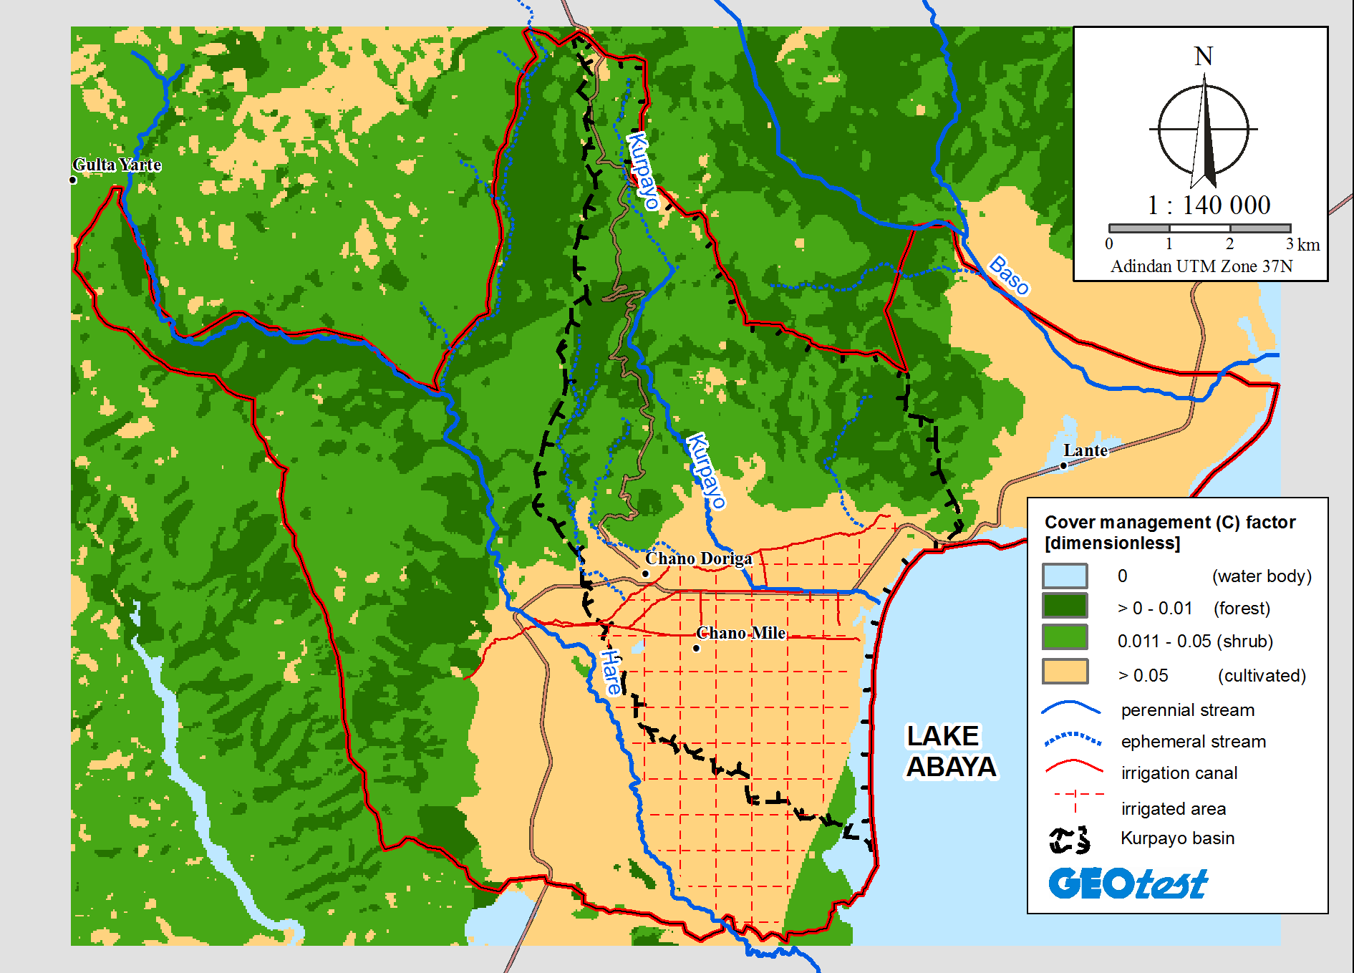
Fig. 4: C-factor

After having all the factors, we use the raster calculator to multiply each factor. The result will be our RUSLE map giving us information about the values in metric tons ha⁻¹ year⁻¹ of soil loss in the study area.
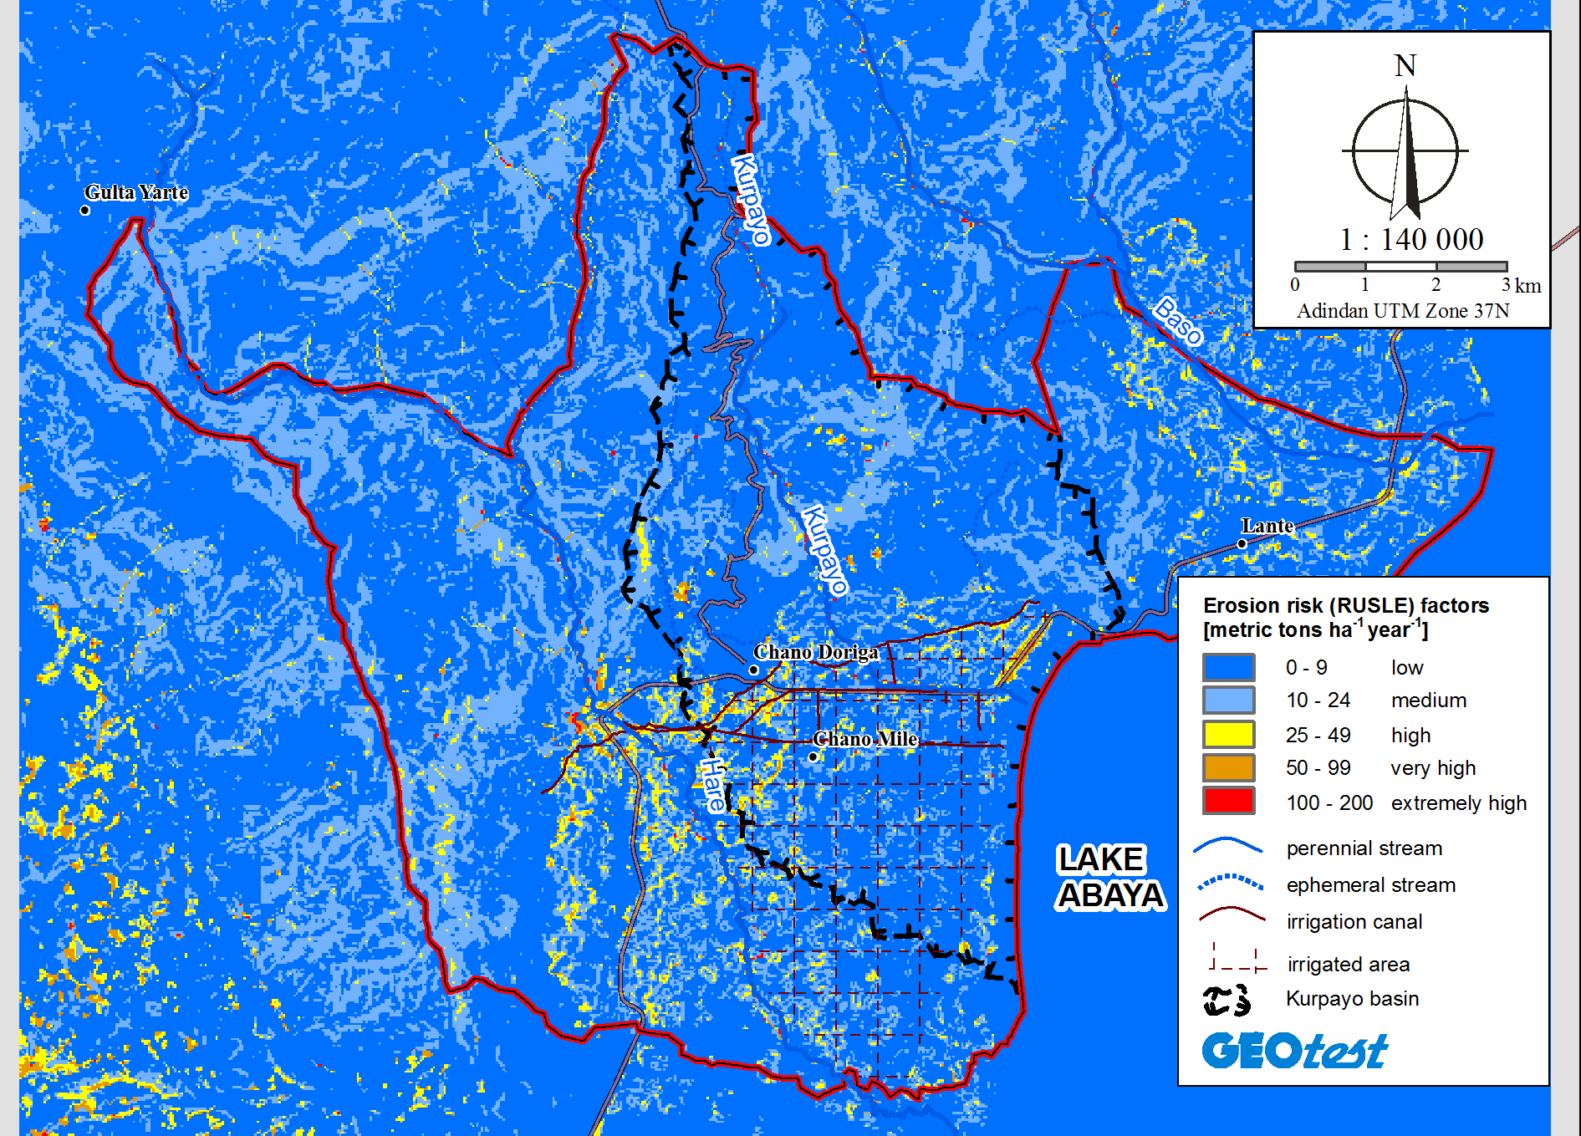
Fig. 5: Risk erosion (soil loss)

MULTITEMPORAL ANALYSIS
The multitemporal analysis is the comparison of different factors through the timeline observing the changes and the tendency of change in one given area.
In this case, the multitemporal analysis consists of the study of the vegetation changes caused by the human action in a determined area (Chamo Mile farm, surrounding of Arba Minch including the mountainous area to the Abaya lake).
As other authors say, “The multitemporal analysis allows to detect the changes between different reference dates, deducting the evolution of the natural environment or the effects of the human actions in this environment” (Chuvieco, 1996). It is therefore that a multitemporal analysis of the land use in a given place can be very useful to identify the most susceptible points and those ones that require the biggest attention, as well as to measure the magnitude of the alteration caused in one given area. In the below, there is another practical example of multitemporal analysis, in this case, it is the study of the waterflow changes in the Ucayali river in Perú.
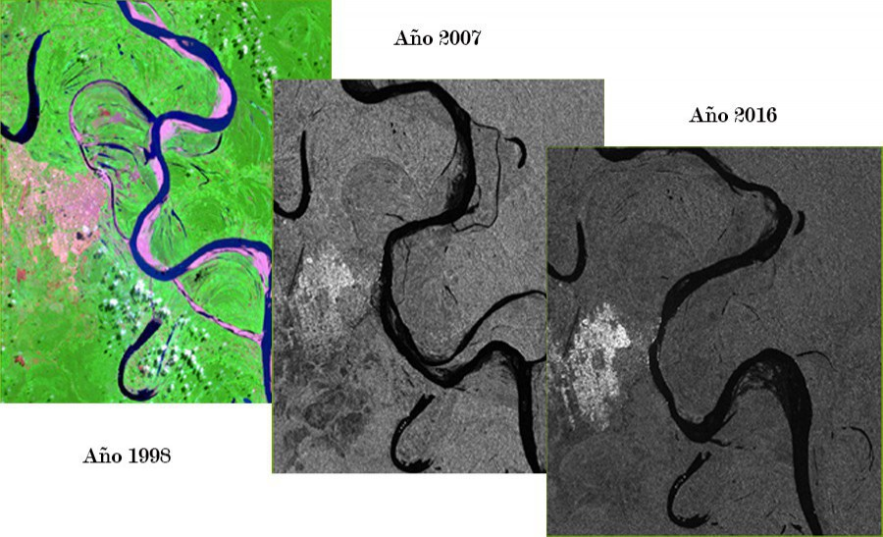
Fig. 6: Ucayali river changes. Picture taken from the Hydrography Direction of the National Marine Administration in Perú
To make a multitemporal analysis, it is necessary to think about some aspects of the analysis, for example, which time intervals can be taken and how many images in that time. In this case, there have been 4 images taken with an average of 10 years between one and the following. The availability of the images depends on the quality of the satellite image, we have to adapt to the data that the different sources offer us, but if we need a satellite image in a determined year and it has clouds (which complicates the visibility), we have to be flexible to change the year up or down in the time.
Thus, in the present guide, as an example, we take the data used for the multitemporal analysis in the study of Hare, Baso and Kurpayo river basins. So, in this case, the multitemporal analysis consists of a study of the temporal evolution and the changes that the land-use shows during 30 years (from 1985 to 2015), with the aim to obtain the value of the deforestation´s impact through the change of the forest cover. At the end, the deforestation rate will be calculated.
The data that is needed to make a multitemporal analysis is:
-Satellite images of all the dates that are important for the study.
Sometimes, there aren’t any free available data sources for the date we need because the satellite images from free sources are limited, referring to the climatic state of the atmosphere. For example, we need one satellite image in a determined date, but this image has clouds just over the area in which we need to work, in this case, we have to be flexible and adapt to the date before or later than the first one.
In a multitemporal analysis through different years, it is important to work with the images of the most similar date possible between years. We have to take into account that we can use images in a range of one month or at least in the same season, regarding the availability of the images from the source and their quality. Also, we will try to get the satellite images from the same satellite model in order to have the same resolution and visualization settings speeding up the work.
Tab. 1: Satellite images from Landsat used in the study
Landsat | Path | Row | Date
TM 5 | 169 | 56 | 15/3/1985
TM 5 | 169 | 56 | 6/2/1995
TM 5 | 169 | 56 | 30/1/2010
TM 8 | 169 | 56 | 28/1/2015

So, in this case, we have taken 4 Landsat satellite images from the USGS (table 1) and one Digital Globe satellite image (that data were paid).

- Software to process all the data:
- ArcGIS 10.3
- ENVI 5.3 environment.

Once we have analysed and decided what area and date of the satellite images we need, we can continue making a visual analysis of the satellite images, in this manner we can have a general idea of the results we will get, but this step is very basic and only gives a first sight of the state of the area.
Depending on the analysis that we decide to do, we can use different combinations of Landsat bands that are different in each Landsat satellite version. The picture below shows the possibilities of bands combination in Landsat 5, 7 and 8 satellites.

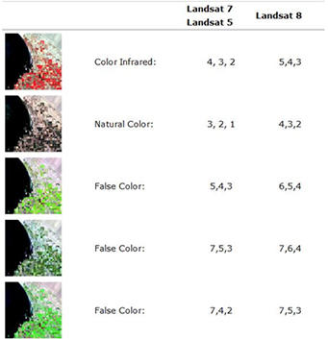
Fig. 7: Landsat 5, 7 and 8 band combinations

In the following picture, it can be observed the four satellite images from Landsat that the previous table shows.
Shown the four Landsat images used in this study with the 4,3,2 band combination in Landsat 5 images and 5,4,3 for Landsat 8, both infrared combinations, which are more sensitive to vegetation. With such combinations, the infrared band is assigned to the red one, the red to the green and finally the green to the blue, in this way the vegetation shows red and brown tones while the water body presents tones blue. Darker tones of red correspond to a more dense forest and the clearer red tone to crops and shrubs. The most vigorous vegetation present clearer red tones. For that, the temporal changes between the four images can be visually differentiated.
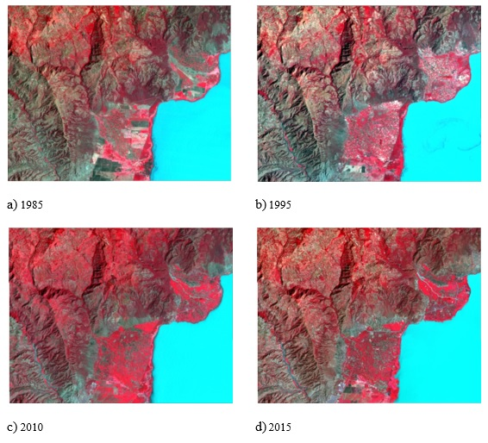
Fig. 8: The Landsat images in infrared combination

Having the satellite images that we are going to work with, the next step is to make a Classification of the vegetation in all of them. This will be a complicated task but this is the key to this multitemporal analysis, is the base that allows us to compare the evolution of the vegetation or the uses of soil in one determined area.
The procedure of Classification of the use of soil or vegetation is described in the document “Classification procedure guidebook”.
Once we have made the classification of all the images, we can start making an analysis of the data obtained. Later, we can see the vegetation classification maps completed in the four satellite images used in the study. In a first sight, the main changes that the area has experimented in the period of time can be observed. Visually the maps show many differences in some of the uses, it means that the area has been exposed to different factors, like climatic changes and human influence.
But to have a better idea of the change, we are going to get the data in numbers and in this way, we will perform a complete analysis through the time in all the uses of soil (or vegetation) in which we focused our classification.
Making the classification, we get raster files of the classification, so we have to transform this raster file into a polygon file (shapefile). Open the raster classification file and follow the path indicated in the picture below in ArcGIS software:
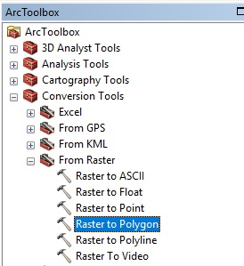
Now we have the whole classification map in shapefile format, in the attribute table, we observe that each land-use has a different GRIDCODE, it means, for example, Forest, Shrub, River, Bare Soil etc. Each of them will have different GRIDCODE but they will be composed of many polygons.
The following step is to analyse if each land-use reflects the reality, so we open the satellite image and the shapefile and we will make a visual analysis of the result. If we find some big mistake in the classification (it can be, because the process does not have a 100% efficiency) we should edit it with ArcGIS tools, but this change has to be made in those areas in which we observe clearly the mistake, for example, we observe in the satellite image one area that is “Urban” but in the classification map it appears like “Road”, in this case, we edit the polygon and we will change the classification in the polygon shapefile. This edition will help us to improve the quality of the classification map, but, it is important to take into account, that we only make this changes in those areas that are clearly differentiated but the process in the software has found difficulties due to the pixel information.
We will edit this change in the attribute table of the polygon, this task will be complex and it will take some time, but the final results will improve considerably. In the picture below, there is an example of the attribute table, in the column “GRIDCODE” we change the number that corresponds to the use of soil we consider in the reality.
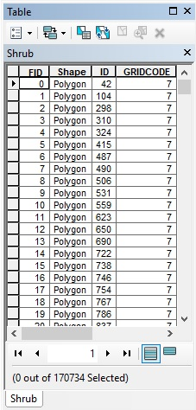
Fig. 9: Attribute table with Gridcode
Once we completed this task (analysing, comparing and checking that all is correct), we proceed to unify each GRIDCODE into one big polygon, is that to say, each GRIDCODE will be one polygon and if our data has 10 different GRIDCODEs (10 different land-uses), we will have 10 big polygons spread in the whole image, so that we can work more easily and efficiently in the following steps.
To unify the GRIDCODES we follow the path shown in the picture below:
We go to the menu “Geoprocessing/Dissolve”:
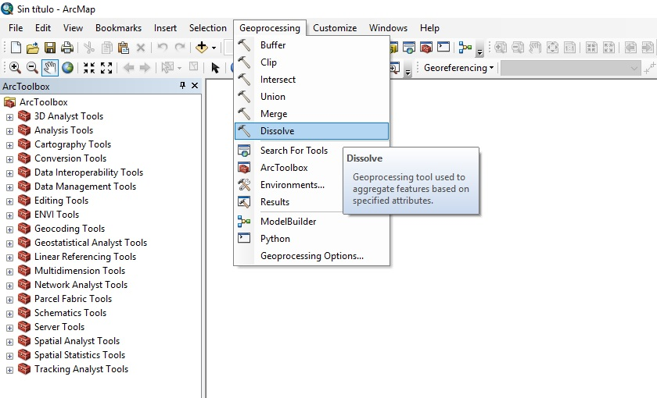
Fig. 10: Dissolve function
In the following menu of Dissolve, we select the file in which we want Dissolve to take place, and in the window below, we select the category in which the dissolve will be applied, we save the file with the same name of the original but adding a final D to distinguish it.
Now, we have all the uses each one being one big polygon. In this way, we can proceed to elaborate the final map, also this detail will help with the process of giving rapidity because it decreases the computational cost of the operation.
Once we have made this procedure in each classification image, we have in this example 4 uses of soil classification maps as shown in the picture below. In a first sight, we can observe the main changes of how the surfaces have changed through the years. But we need numbers.

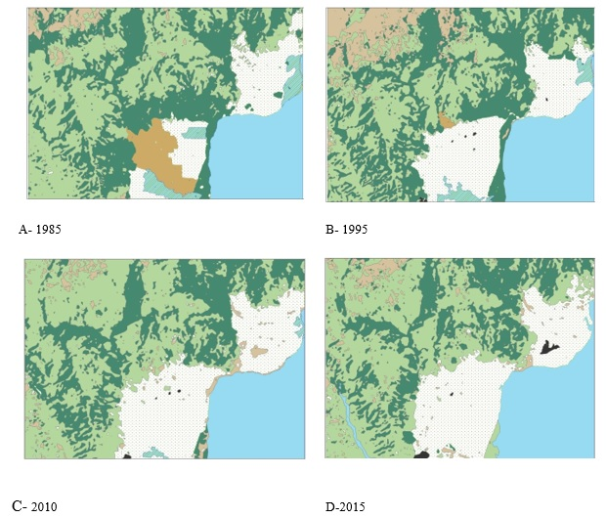
Fig. 11: Example of multitemporal classification taken from the study of the rural area next to Arba Minch
So, to calculate the exact surface that we have in each use, we go to the Attribute table of each map and create a New Field called “Area”, and pressing the right mouse button we select “Calculate Geometry” option as shown in the pictures below. With this option we can select in which units we want to calculate it, in this example, we calculate the surface in hectares.
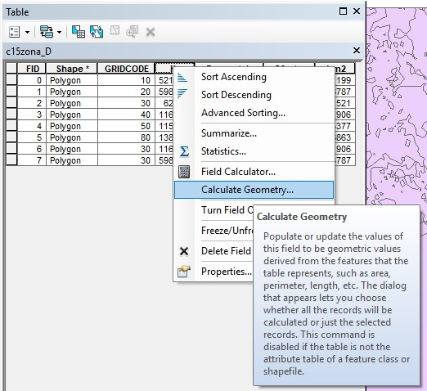
Fig. 12: Calculate Geometry
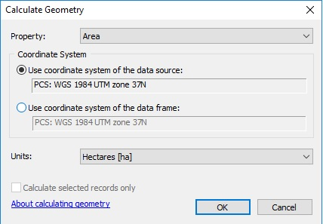
Fig. 13: Calculate geometry menu
After performing this application in all the maps, we generate a table with all the data compiled, an example is shown in a table below. This table was generated in the study of the multitemporal analysis in Arba Minch-Chamo Mile area. The table is composed of the total surface and its correspondent percentage in relation with the total of each use of soil that is present in the area.
Having this complete table, the observation and analysis of the data are much clearer and there can be seen the evolution of one use of soil determined. The evolution of the area is reflected in the table.
If we check the attribute table of the new file, we will see that there is only one polygon of each type. We create a new field in which the value of the area of each polygon will appear. We can calculate it in squares meters, hectares, there are many options, in this case, we will use hectares and we will create a new field called “Ha”. Once we have this new field, we calculate its value by clicking with the right mouse button and selecting “Calculate geometry”, there we have to select, in which units we want the result, and press ok. Automatically, the value of each polygon will appear.
We complete this procedure with all the classified images we have, and once we have the statistics of all of them, we can start analysing the data and observing the evolution and researching the reason of changes more deeply.
In the table below, there are the results of the analysis made to the 4 satellites images in different years. We can appreciate the change of the data and its percentage, to have the data in percentage is very useful to have an idea in a first sight, but now, with the exact surface in hectares of each use of soil, we can make an exhaustive analysis of the changes and detect what are its origins.
Tab. 2: Ha per use of soil in each year of the multitemporal analysis
 | 1985 |  | 1995 |  | 2010 |  | 2015
Use | Ha | % | Ha | % | Ha | % | Ha | %
Water | 4710,6 | 15,5 | 4665 | 15,3 | 4813,3 | 15,8 | 5211,9 | 17,1
Forest | 8829,9 | 29 | 8632,6 | 28,3 | 6818,9 | 22,4 | 5972,8 | 19,6
Crop | 3489,5 | 11,5 | 4991,6 | 16,4 | 6295,2 | 20,7 | 6286 | 20,6
Shrub | 10285,9 | 33,8 | 8725,7 | 28,6 | 11453,9 | 37,6 | 11671,7 | 38,3
Small shrub/naked | 970,5 | 3,2 | 2786,3 | 9,1 | 864 | 2,8 | 1153,7 | 3,8
Transformation | 1303,9 | 4,3 | 82,9 | 0,29 | --- | --- | --- | ---
Wetland | 842,7 | 2,7 | 497,2 | 1,64 | 141,9 | 0,5 | --- | ---
Artificial (Urban) | --- | --- | 53,7 | 0,2 | 47,8 | 0,2 | 138,9 | 0,46

COMPARISON BETWEEN TWO DATES
The study of the change of the use of soil can be made by comparing the changes between two dates, we have many possibilities for example, between 5, 10, 15 or 30 years like in this case.
Thus, we will generate a land-use change map to show the areas that have changed and identify, which of them have changed most. For that, we take part from a classification vegetation map of each satellite image in this case (dates 1985 and 2015), 30 years of difference. We can use the data that we have generated in the study before (multitemporal analysis).
To generate the change map, we need to work with the attribute table of each image. Firstly, we have to assign determined values to each use, for that, we will create a new field in the attribute table called “Code”. The code that will be assigned to each use will be according to the following key. It will depend on the number of uses we have, moreover, this is a guide and the number and keys used can be changed by the user.
So, the key to follow in the assignment of the number will be following:
More recent image |  | water | forest | crop | shrub | Bare soil | urban
Older image |  | 10 | 20 | 30 | 40 | 50 | 80
water | 1 | 11 | 21 | 31 | 41 | 51 | 81
forest | 2 | 12 | 22 | 32 | 42 | 52 | 82
crop | 3 | 13 | 23 | 33 | 43 | 53 | 83
shrub | 4 | 14 | 24 | 34 | 44 | 54 | 84
Bare soil | 5 | 15 | 25 | 35 | 45 | 55 | 85
transformation | 6 | 16 | 26 | 36 | 46 | 56 | 86
wetland | 7 | 17 | 27 | 37 | 47 | 57 | 87

In blue colour, there is the code corresponding to the uses in the older image (1985 in this case), and in green colour, there is the code that will be assigned to the more recent image (2015). For example, the use “water” has code “1” in 1985 and code “10” in 2015, we assign this numbers because we need to detect the tendency of each use, and we will know it when we add both images. The result of each addition will give us the information of what use has the soil nowadays.
After modifying the attribute table of each image, we convert each shapefile into raster file in order to use the tool “Raster Calculator”. The following table shows the possible results that we can obtain:

Remain water | 11
Forest to water | 12
Crop to water | 13
Shrub to water | 14
Bare soil to water | 15
Transformation land to water | 16
Wetland to water | 17
Water to forest | 21
Remains forest | 22
Crop to forest | 23
Shrub to forest | 24
Bare soil to forest | 25
Transformation to forest | 26
Wetland to forest | 27
Water to crop | 31
Forest to crop | 32
Remain crop | 33
Shrub to crop | 34
Bare soil to crop | 35
Transformation to crop | 36
Wetland to crop | 37
Water to shrub | 41
Forest to shrub | 42
Crop to shrub | 43
Remain shrub | 44
Bare soil to shrub | 45
Transformation to shrub | 46
Wetland to shrub | 47
Wáter to bare soil | 51
Forest to bare soil | 52
Crop to bare soil | 53
Shrub to bare soil | 54
Remain bare soil | 55
Transformation to bare soil | 56
Wetlando to bare soil | 57
Wáter to urban | 81
Forest to urban | 82
Crop to urban | 83
Shrub to urban | 84
Bare soil to urban | 85
Transformation to urban | 86
Wetland to urban | 87

Once we have made the addition of the raster, we transform the result into the shapefile. We go to the attribute table of the shape and there we can observe a column with the numbers corresponding to the values that appear in the table above. We create another column beside this one and we will name it like “Change”. Then we write the change, that corresponds to each number, into this column. Thus, we can generate a land-use change map with the complete legend.
Now we will create another column called “change2”, and in those places that changed, we will write “change” and in those ones, that not, we will write “Remain”. In this way, we can generate a map that shows what areas of the total one changed and those ones that not.
The picture below is an example of how it the use of soil change map should look like. We can observe many different colours in small areas, this is because we are working with many possibilities, some of them can be mistaken, all depend on the quality of the classification vegetation map.
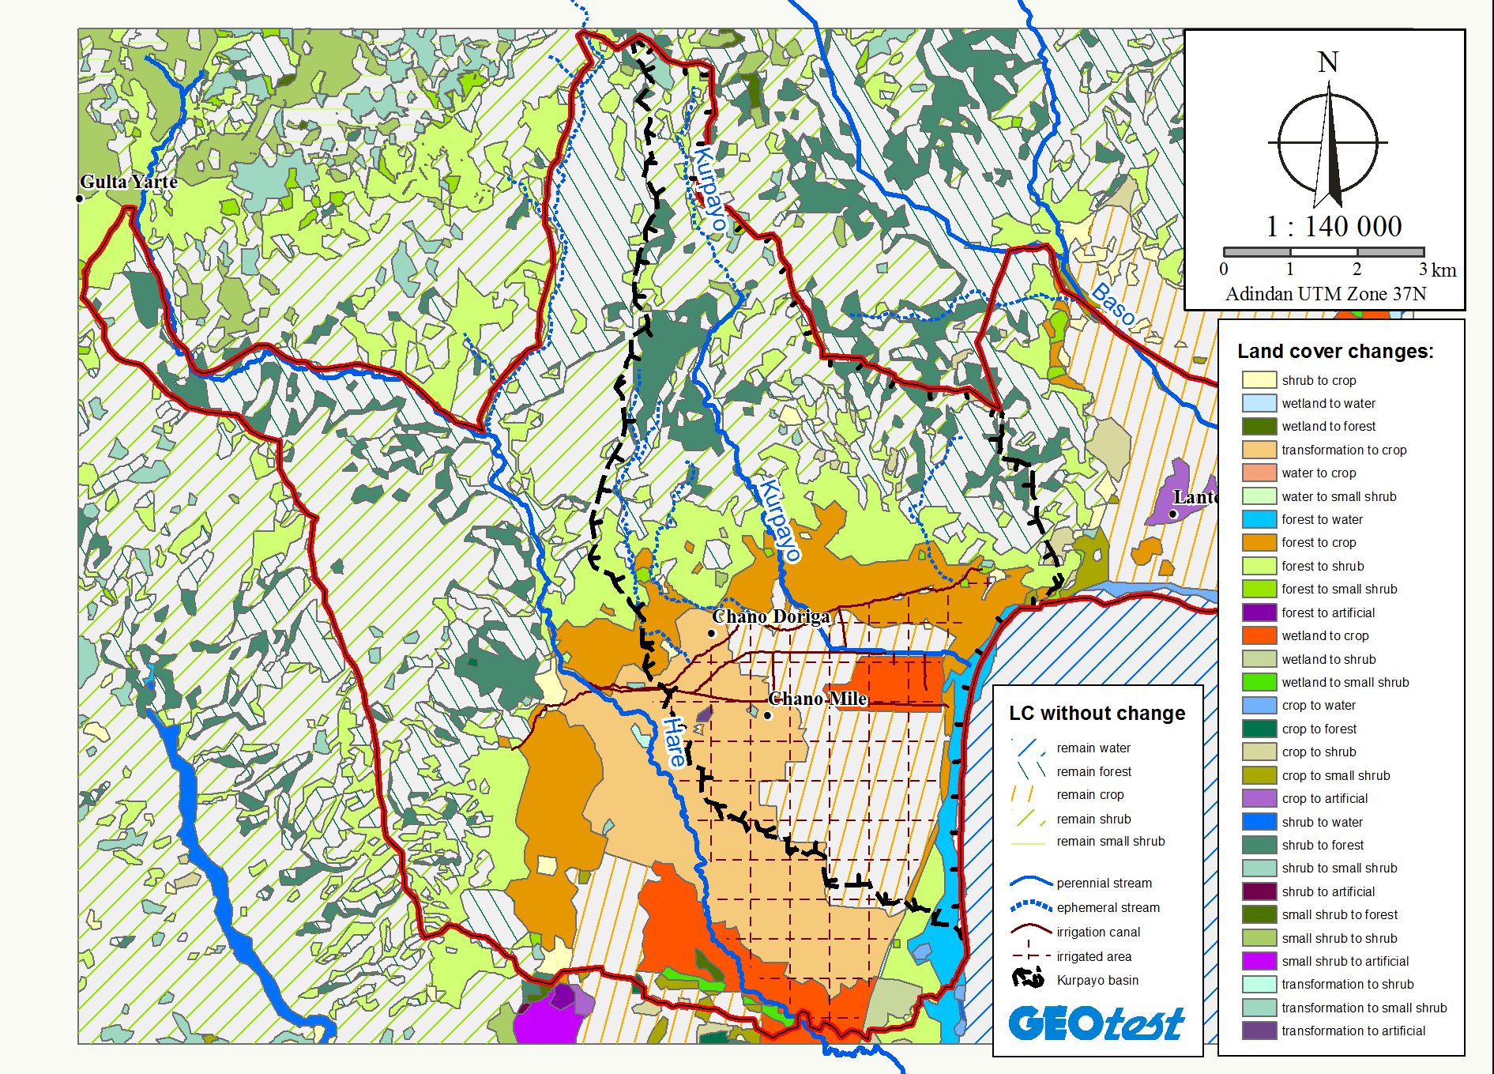
Fig. 14: Land cover changes
Once obtained the different type of soil use from the classified image, the deforestation rate was calculated through the following equation proposed by FAO (1996):

$$t=1-{(S_{2 }/ S_{1 })}^{\frac{1}{n}}$$

Where:

T= Deforestation rate (%).
S₁= Forest surface in date 1.
S₂= Forest surface in date 2.
n = Number of years.

So, we can observe, how the forest surface in was in 1985 in this case (S₁) and in 2015 (S₂) and carry out the previous equation to know the deforestation rate in %. Also, the total percentage of forest that has been lost can be calculated. This option gives us much more useful information.
Another map can be generated, it is the tolerance of soil lost map. Some authors have found that the limit of tolerance of the soil loss is 10 tons per ha/year, so we can generate a map that shows which parts of the area belong to less than 10 tons per ha/year and which over that, to detect what areas are the most vulnerable to the erosion.
For this task, we go to the erosion map in shapefile format, we go to the attribute table, we create another column called “limit tolerance” and we write if the value is up or down to 10 ha in each level of erosion. For example, the first value is from 0 to 10 tons, in this value we write “under” in the new column we have created, from the second value to the sixth, we write “over” or “up” to say that, in these values of erosion, we are over 10 tons.
After completing the attribute table, we can generate the map by going to the settings and selecting that we have to classify our map with the “limit tolerance” classification. After creating the map, we can change the legend writing the symbol < 10 or > 10 to describe the result.
Finally, the map will look like the following one:
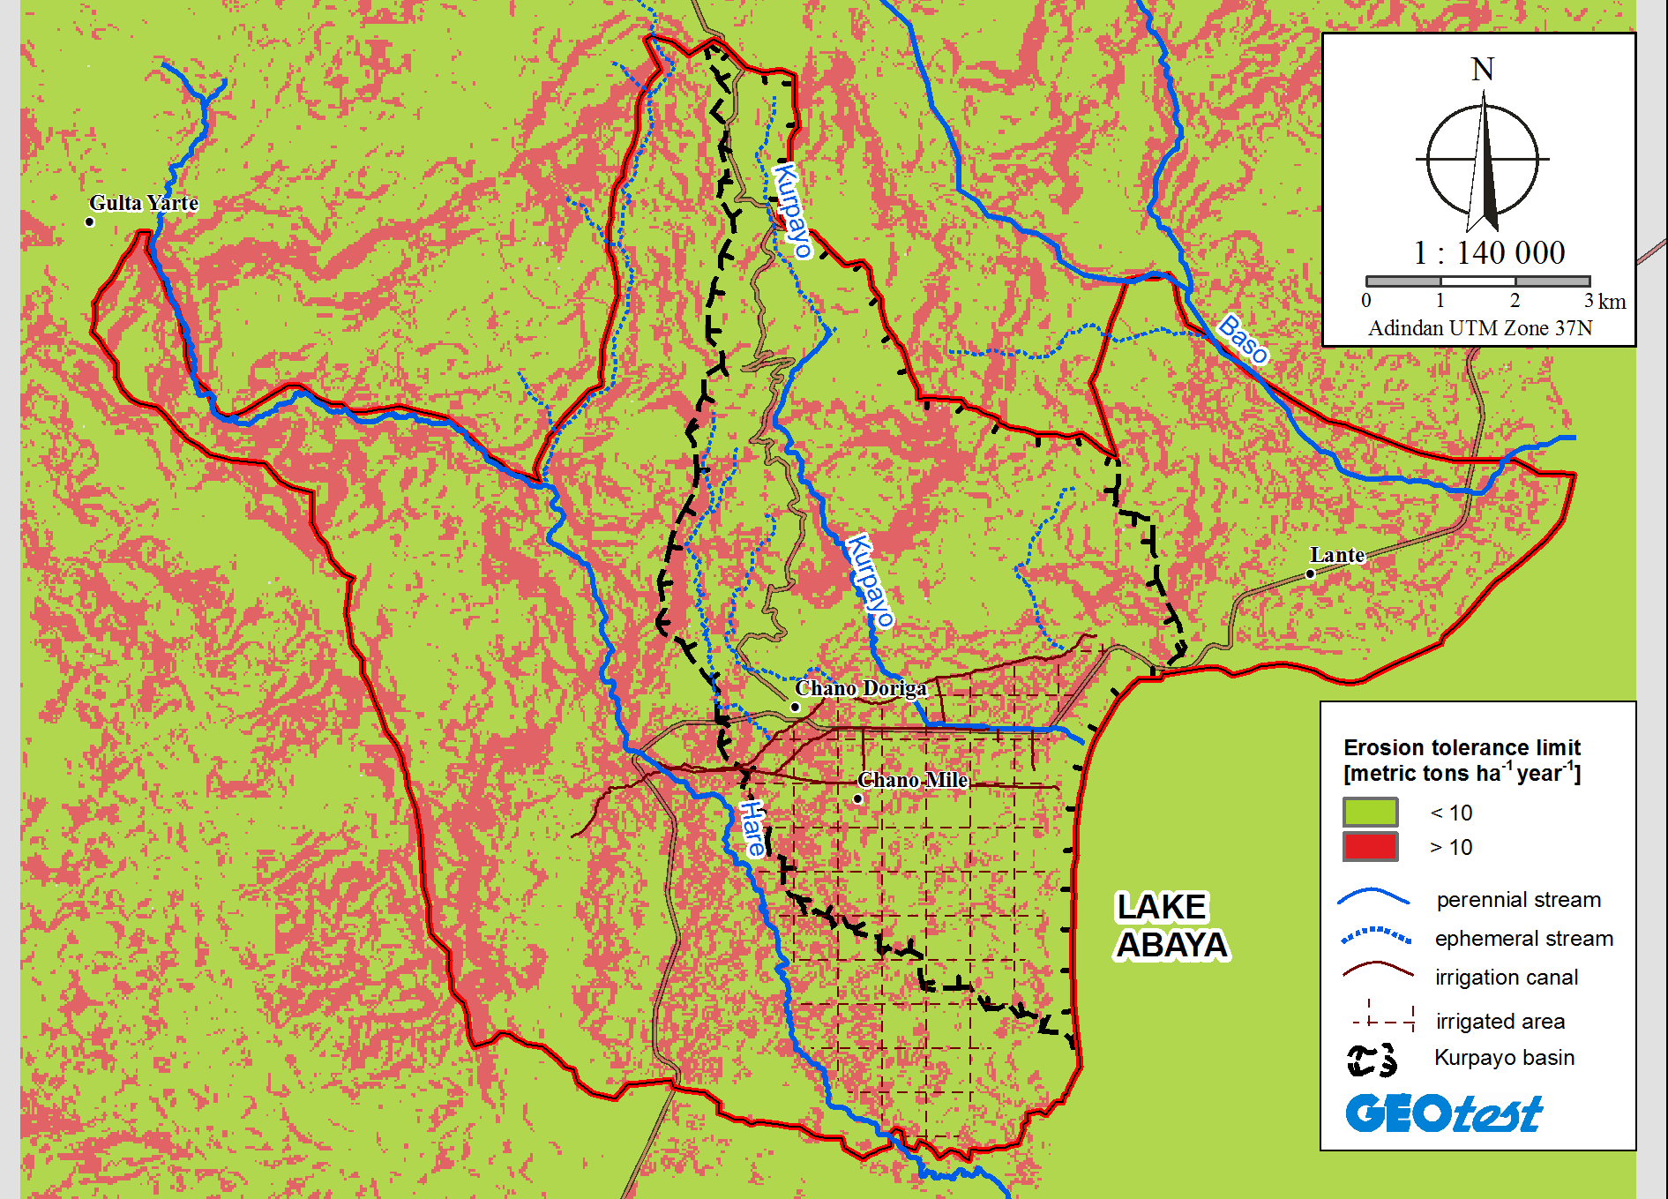
Fig. 15: Erosion tolerance limit

