Baseline Survey findings on the recent practices of FTCs at the targeted areas
Alem Tesfaye, June, 2016
Crops currently demonstrated at target FTCs
Woreda | FTCs | No of Crops | Crops they are growing
Sankura | MENZO | 7 | Maize, Haricot bean, Teff Wheat, Pepper, Sorghum, Corn
 | W/SIMBITA | 3 | Maize, wheat. Teff
 | BARCHO | 5 | Maize, Teff, Wheat, Haricot bean, Sorghum
 | FETEN | 4 | Maize, Haricot bean, Teff, Wheat
 | BARCHO KULUFO | 3 | Maize, Wheat, Teff
 | WETETA | 6 | Maize, Corn, Haricot bean, potato, wheat, Teff,
 | MENZO FETEN | 8 | Teff, Wheat, Haricot bean, Maize, Potato, Sorghum, Corn, Barley
Halaba | SIMBITA | 4 | Maize, Wheat, Teff, haricot bean
 | BENDO CHOLOKSA | 4 | Maize, Sorghum, Teff, Haricot bean
 | KULUBE | 4 | Maize, Sorghum, Teff, Haricot bean
 | BESHENO | 9 | Maize, Corn, sorghum, Haricot bean, wheat, Barley, Pea, Chick pea, Teff
 | HANTAZO | 8 | Maize, Corn, Sorghum, Haricot bean, Wheat, Pepper, Teff, Barley
 | WETETA | 4 | Maize, Sorghum, Wheat, Teff
 | KULUFO | 8 | Sorghum, Haricot bean, Maize, Corn, Potato, pepper, Teff, Wheat

From the targeted 14 FTCs four (4) of the promote at least 8 types of crops and these are from Sankura Woreda, Menzo Feten promotes 8 crops and from Halaba Woreda Besheno, Hantazo and Kulufo promoting 9,8 ,8 types of crops respectively, that means only 28.6% of the FTCs are currently promoting at least 8 types of crops. The targeted FTCs grow 6 crops on average. Using the full sample of FTCs in the targeted Kebeles, it’s found out that maize and Teff are the most commonly produced crops, with almost all of the FTCs surveyed reported that they grow the crops, following by wheat which is being grown by 13 FTCs.
Fodder grass production at FTCs
Woreda | FTCs | Total area in hectare | Total fodder grass area in hectare
Sankura | MENZO | 3 | 0.125
 | W/SIMBITA | 2.5 | 0.125
 | BARCHO | 2.64 | 0.5
 | FETEN | 2 | 0.08
 | BARCHO KULUFO | 3 | 0.25
 | WETETA | 3 | 0.25
 | MENZO FETEN | 2.25 | 0.25
Halaba | SIMBITA | 4 | 0
 | BENDO CHOLOKSA | 3.5 | 0.06
 | KULUBE | 1.75 | 0.25
 | BESHENO | 3.5 | 0.06
 | HANTAZO | 1.5 | 0.06
 | WETETA | 1.5 | 0.12
 | KULUFO | 2 | 0.25

The targeted FTCs have 2.6 hectare land on average which is almost similar in both Halaba and Sankura Woredas and they only use only 6.6 percent of their total land to grow fodder grass and one of the FTCs (in Halaba Woreda Simbita Kebele) currently does not grow any fodder grass at all.

Agricultural practices promoted by the FTCs
Graph 1: Trends of FTCs on the promoted practices
FTCs | Intercropping | Crop rotation | Sowing inline | Use of organic fertilizer | Mulching(residue cover | Minimum tillage
MENZO | NO | YES | YES | YES | NO | YES
W/SIMBITA | YES | YES | YES | NO | NO | YES
BARCHO | NO | YES | YES | YES | YES | NO
FETEN | YES | YES | YES | YES | YES | NO
BARCHO KULUFO | NO | YES | YES | NO | NO | NO
WETETA | YES | YES | YES | YES | YES | NO
MENZO FETEN | NO | YES | NO | YES | YES | NO
SIMBITA | NO | YES | YES | NO | NO | NO
BENDO CHOLOKSA | YES | YES | YES | YES | YES | YES
KULUBE | NO | YES | YES | NO | YES | NO
BESHENO | NO | YES | YES | NO | YES | NO
HANTAZO | YES | YES | YES | YES | YES | NO
WETETA | NO | YES | YES | NO | NO | NO
KULUFO | YES | YES | YES | NO | NO | NO

Regarding the promoted good farming practices, equal number of FTCs in Halaba and Sankura Woredas (42.9%) demonstrate intercropping in their plot and all (100%) FTCs both in Halaba and Sankura Woredas demonstrate crop rotation. While 85.7% of the FTCs in Sankura Woreda currently demonstrate sowing in line, all FTCs in Halaba Woreda (100%) demonstrate sowing in line. 71.4 % of the targeted FTCs in Sankura demonstrate use of organic fertilizer and only 28.65 of the targeted FTCs in Halaba demonstrate it. 57.1% of FTCs both in Halaba and Sankura Woredas demonstrate mulching and only 28.6% and 14.3% of the FTCs demonstrate minimum tillage in Sankura and Halaba Woredas respectively.
FTC outreach to prevent soil erosion
Graph 2: FTCs currently encouraging farmers to discuss the risks and options for soil erosion prevention/treatment
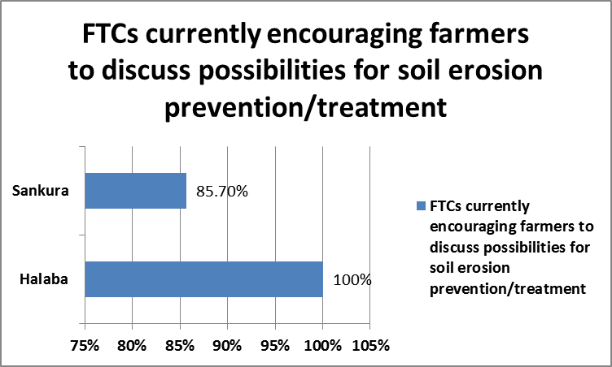
Regarding soil erosion 85.7% of FTCs in Sankura Woreda encourage farmers to discuss about possibilities for soil erosion prevention/treatment while all (100%) of the targeted FTCs in Halaba stated that they do so.
The vast majority of the FTCs 93% do not currently provide supplies of inputs for required anti-erosion measures while only one of the FTCs (Sankura Woreda Weteta Kebele) grows cordis-africana, grevillea and Junipers to provide it to the farmers. The other FTCs explained that they don’t get the seedlings sufficiently due to financial limitations and due to the fact that the area has water scarcity. Almost all of the FTCs stated that due to budget limitations they are not giving sufficient support to the farmers in treating/preventing erosion at their own fields, providing field-based demonstration (including growing trees at the FTCs, see last section) but they point out that they let the farmers know at least some of the negative consequences of soil erosion like flood, reduction of productivity and land degradation.

 | Menzo | W/Simbita | Barcho | Feten | B/kulufo | Weteta | M/Feten | Simbita | B/CHELOKSA | Kulube | Besheno | Hantazo | Weteta/Halaba | Kulufo
Growing agro-forestry crops | YES | YES | YES | YES | NO | YES | YES | NO | YES | YES | NO | YES | NO | NO
Providing agro-forestry crops to community | NO | NO | NO | NO | NO | YES | NO | NO | NO | NO | NO | NO | NO | NO
Demonstrating beekeeping | YES | NO | NO | NO | NO | YES | YES | NO | NO | NO | NO | NO | NO | NO
DAs conducting community conversations | YES | YES | YES | NO | YES | YES | NO | YES | YES | YES | YES | NO | NO | NO
FTCs with agreement with community on over grazing | YES | YES | NO | YES | NO | YES | YES | NO | NO | YES | NO | YES | NO | NO
FTCs with Das who know about the three conservation agriculture principles | NO | NO | NO | NO | NO | NO | YES | NO | NO | NO | NO | NO | NO | NO
FTCs with water shade camping | YES | YES | YES | YES | NO | YES | YES | YES | YES | YES | YES | NO | NO | YES

The FTCs were asked if they have any agreement with the community about over grazing and 4 FTCs (Feten, Barcho kulufo, Weteta and Menzo Feten) have agreement with the community to plant fodder grass, 2 FTCs (kulufo and Hantazo) on replanting the over grazed area and one FTC (Sankura Woreda, Weteta Kebele) has agreement to isolate people who over graze from social settings like ‘Idir’.
11 of the FTCs undertake Water shade campaign with the communities in which they plant trees and construct Terracing every year in a mass on the common lands of the community.
It is found out that bee keeping is not a common trend in the targeted areas and only three FTCs in Sakura demonstrate bee keeping and none of the targeted FTCs in Halaba demonstrate bee keeping.
The vast majority (six) of the FTCs demonstrate agroforestry trees in Sankura woreda while only 3 of the targeted FTCs in Halaba demonstrate agroforestry.
Only DAs from Menzo feten FTC know about the three conservation agriculture principles and the remaining Das from 13 FTCs do not know anything about it.

FTCs trainings
Trainings | Menzo | W/Simbita | Barcho | Feten | B/kulufo | Weteta | M/Feten | Simbita | B/CHELOKSA | Kulube | Besheno | Hantazo | Weteta/Halaba | Kulufo
sowing in line |  |  | X | X | x | X | X
crop production |  | X | X |  |  | X
water shade campaign |  |  |  |  |  |  |  |  |  |  | x | x
natural resource management | X | X
animal husbandry | X | X
Irrigation |  |  |  |  |  |  |  |  | x | x | x | x
Skill training |  |  |  |  |  |  |  | x
Input usage |  |  |  |  |  |  |  |  |  |  |  |  | x

In most of the FTCs, the Das themselves didn’t get comprehensive and sufficient amount of trainings and most of the trainings they received are about sowing in line, crop production, water shade campaign, natural resource management, animal husbandry and Irrigation. Das in one of the FTCs (Kulufo) did not get any kind of training yet.

