Graphic Manual

Czech Republic Development Cooperation – 17 August 2007

Logo with the Czech text

Intended primarily for communication in the Czech Republic (for a Czech language environment).

Logo with the English text

Intended primarily for communication of the Czech foreign development cooperation at the international level.

Graphic Manual of the Czech Republic's Foreign Development Cooperation

This manual is used to ensure a uniform use of the logo. On its website you will find the basic rules for using the logo. Observe the prescribed colour and protection zone.

The CD-ROM in the appendix contains a manual in the PDF format and the logo in the Czech language "Česká republika pomáhá" in a horizontal and vertical version, as well as the logo in English "Czech Republic Development Cooperation"

The logos are saved in the Office folder (common formats for office use); the Professional folder includes a logo saved in a curved form and in formats standard for graphic use.

The appendix includes materials for the implementation of secondary graphic elements.
Graphic Manual

Czech Republic Development Cooperation – 17 August 2007

Content of the Manual

Logo appearance-Horizontal logo variants | 4 | Additional graphic elements – definition of colours | 19
Protection zone of the horizontal logo | 5 | Printed matter – example of a cover page layout | 20
Protection zone of the vertical logo | 6 | Printed matter – Example of a layout of the inner sides | 21
Definition of the basic colours | 7 | CD label a booklet | 22
Basic fonts of communication | 8 | Poster | 23
Basic and minimum size of a logo |  | Business card | 24
with the Czech text | 9 | Thank you card | 25
Basic and minimum size of a logo |  | Self-adhesive label | 26
with the English text | 10 | Letterhead | 27
Logo on the background | 11 | Cover page of a brochure
Black and white logo on the background | 12 | of a Microsoft Word document | 28
Logo on a different background | 13 | PowerPoint presentations | 29
Prohibited logo variants | 14 | Identification card | 30
Horizontal logo in conjunction with another logo | 15 | General rules for locating a logo
Vertical logo in conjunction with another logo | 16 | on web presentation pages | 31
Envelope (left upper corner) | 17
Additional graphic elements
– basic three variants of logo compositions
and new graphic elements. | 18

Graphic Manual | 2

Czech Republic Development Cooperation – 17 August 2007

Colour variant Colour negative variant

Monochrome variant Monochrome negative variant

Black and white variant Black and white negative variant

Logo appearance

The logo is designed in several variants.

The basic variant of the logo is colour positive.

We prefer to use this variant.

The monochrome variant is intended for monochrome printing.

The black and white variant of the logo is used for black and white printing.

The box below the negative variant is only illustrative and is not part of the logo.

Graphic Manual
3

Czech Republic Development Cooperation – 17 August 2007
Colour variant Colour negative variant
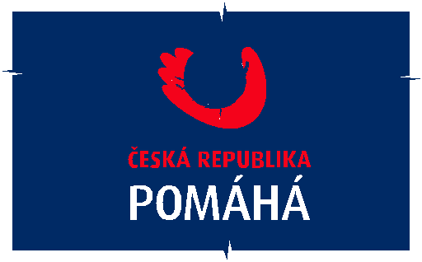

Logo appearance

Horizontal logo variants

The horizontal logo is a special additional variant designed primarily for very narrow formats.

The logo with the English text does not have a vertical variant.

Monochrome variant | Monochrome negative variant

Black and white variant | Black and white negative variant

Graphic Manual
4

Czech Republic Development Cooperation – 17 August 2007

Protection zone

of the horizontal logo

The logo is located in the protection zone.

The protection zone clearly separates the logo

from the other text and graphic elements that would

impair its legibility.

The protection zone of the logo with the Czech text is defined

by the height of the letter "H".

The protection zone of the logo with the English text is defined

by the height of the letter "I".
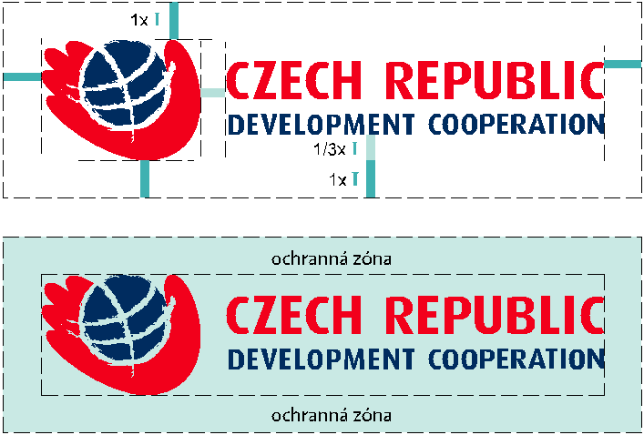

Graphic Manual
5

Czech Republic Development Cooperation – 17 August 2007
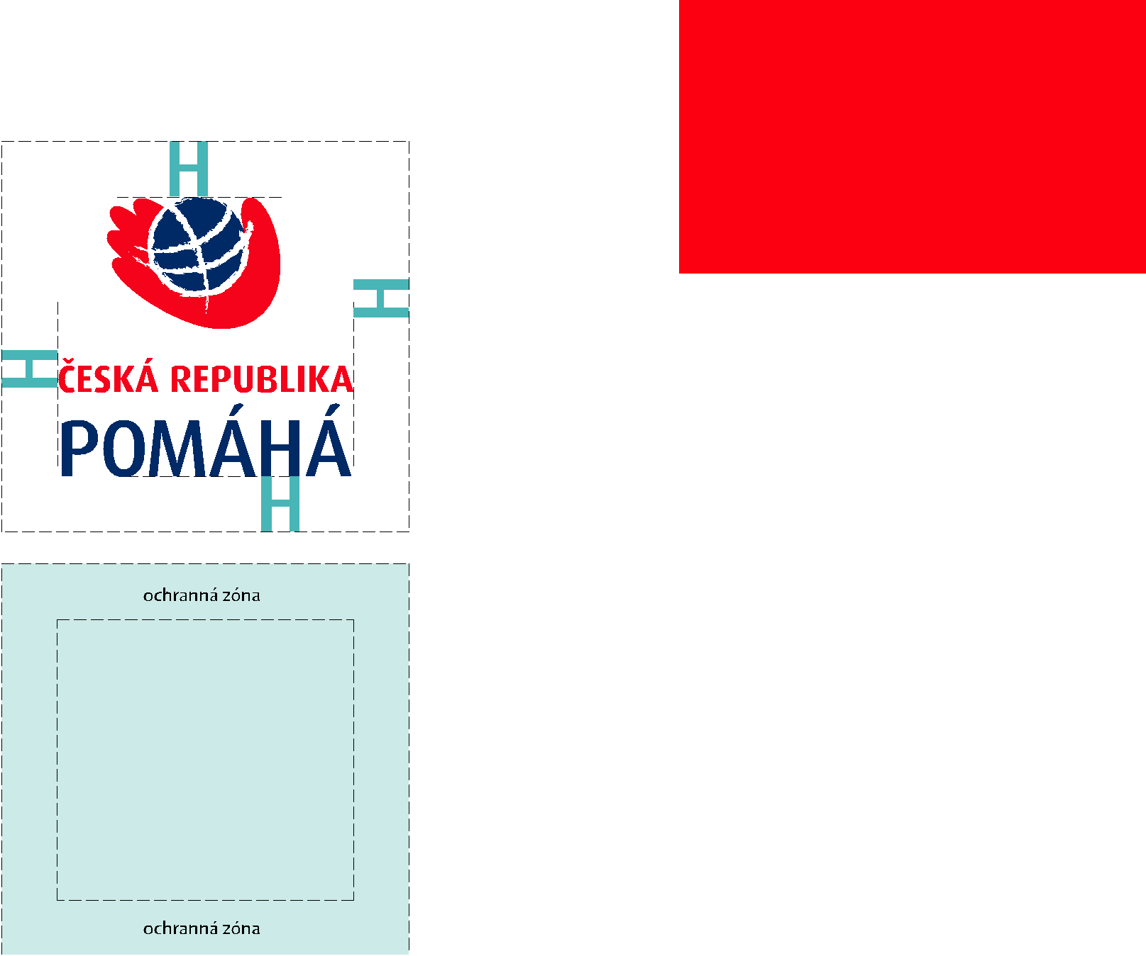

Protection zone

of the vertical logo

The logo is located in the protection zone.

The protection zone clearly separates the logo

from the other text and graphic elements that would

impair its legibility.

The protection zone is defined by the height of the letter "H".

Graphic Manual
6

Czech Republic Development Cooperation – 17 August 2007

Blue

CMYK

100/40/0/40

PANTONE Solid Coated

PANTONE 302 C

RGB

0/85/128

HTML

# 005580

Red

CMYK

0/100/100/0

PANTONE Solid Coated

PANTONE 1795 C

RGB

234/33/39

HTML

# EA2127

Definition of the basic colours

The conversion table lists the colour specifications for different methods of use:

Direct colours Pantone C (Solid Coated) for printing on coated papers (matt and glossy chalk), registration inks CMYK, RGB for electronic imaging, HTML inks for use in Internet applications.

Graphic Manual
7

Czech Republic Development Cooperation – 17 August 2007

Basic fonts of communication

Arial
Typeface © The Monotype Company

This font is suitable for subtitles, larger headings

and highlighting.
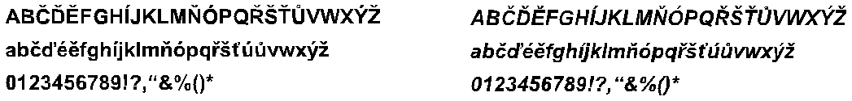

Times New Roman
Typeface © The Monotype Company

This font is suitable for "smooth" typesetting

(long texts).
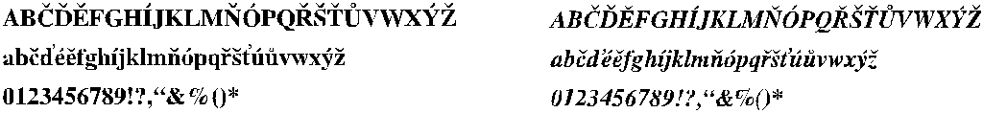

Graphic Manual
8

Czech Republic Development Cooperation – 17 August 2007
0 mm | 20 mm | 50 mm | 75 mm | 100 mm | Basic and minimum size  of a logo with the Czech text
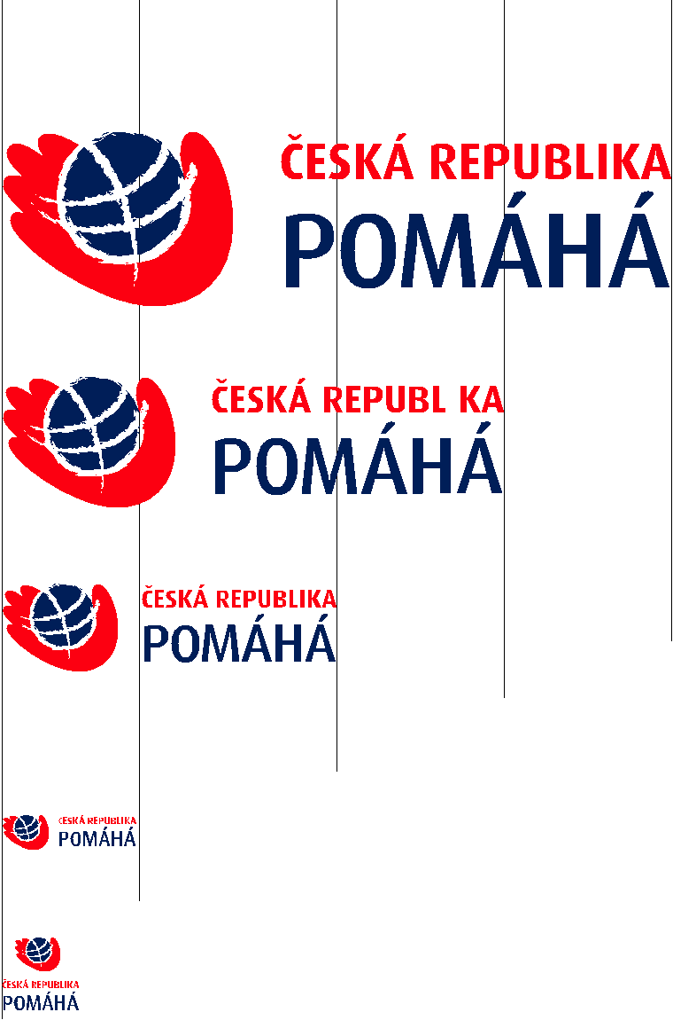

The basic size of the horizontal logo is 100 mm / 100 %.

100 % | In this size, the logo is stored on the enclosed CD.

The minimum size of the horizontal logo is 20 mm / 20 %.

The basic size of the vertical logo is derived from the graphic part.
The graphic part is of the same size in both variants.
75 %
The minimum size of the vertical logo is 11,5 mm / 20 %.

50 %

20 % | 20 mm = minimum size

20 %

11.5 mm = minimum size

Graphic Manual
9

Czech Republic Development Cooperation – 17 August 2007

Basic and minimum size
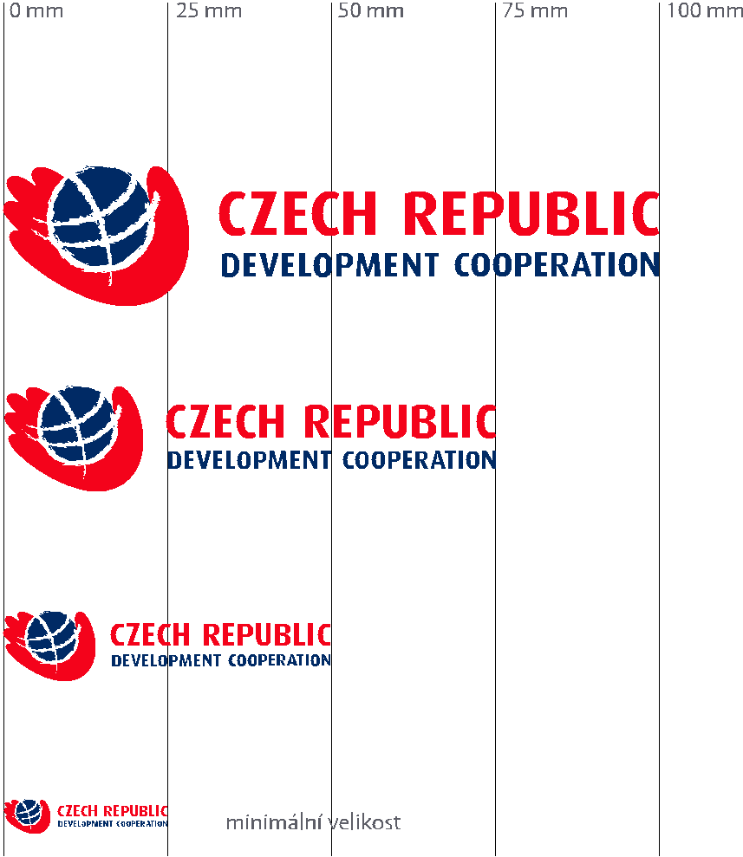
of a logo with the English text

The basic size of the logo is 100 mm / 100 %.

In this size, the logo is stored on the enclosed CD.

The minimum size of the logo is 25 mm / 25 %.

Graphic Manual
10

Czech Republic Development Cooperation – 17 August 2007
1. Application on a calm background (grey scale) 2. Application on a calm background (colourful light)
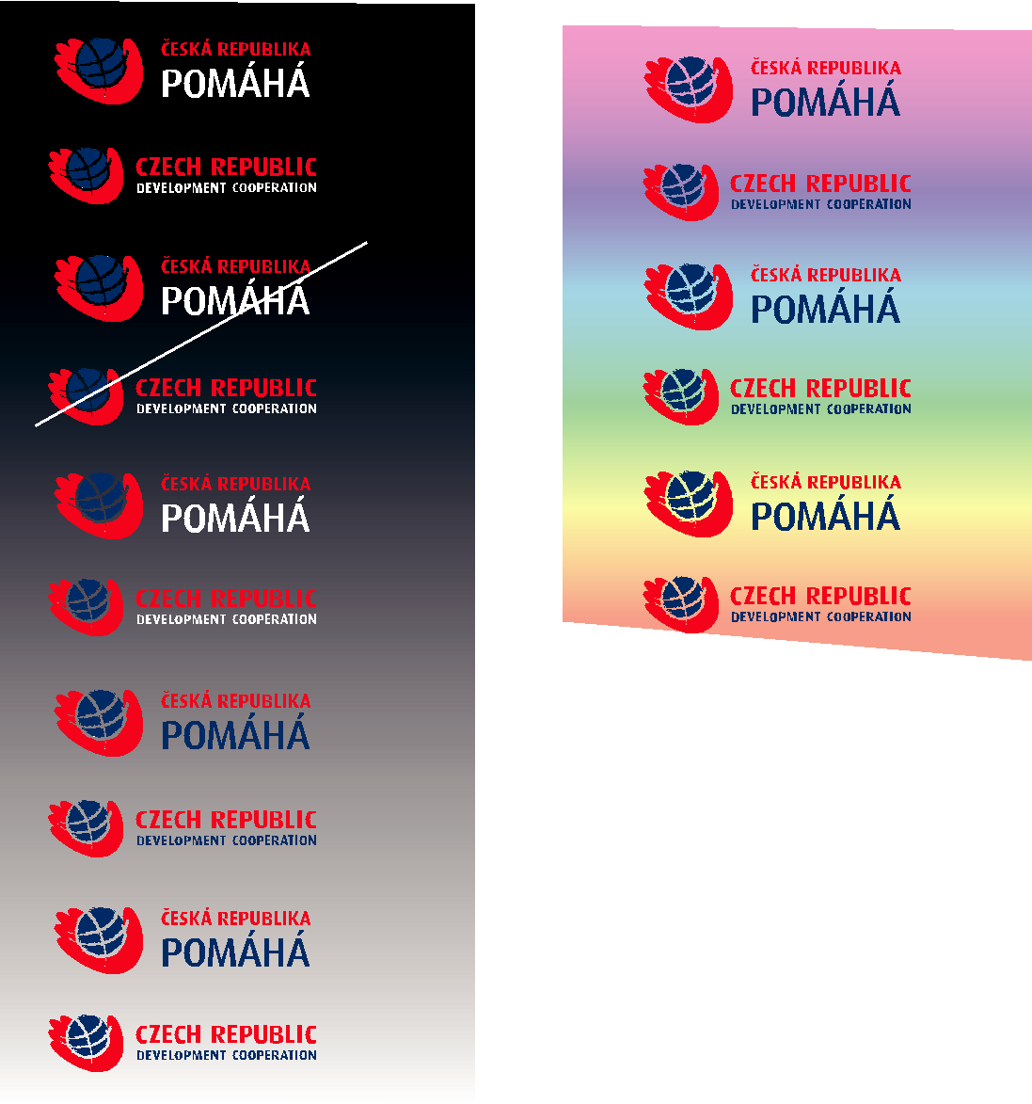

3. Application on a calm background (colourful dark)

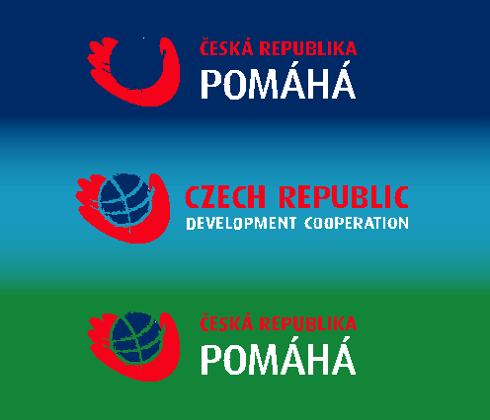

Logo on the background

Logo on a calm background – different background colour shades require the selection of the corresponding logo from the stored data.

When applied to a coloured background, the main criterion for selecting a logo is its good visibility and legibility. Do not use a logo on the background that reduces visibility.

When the logo is applied on a monochrome

background, the colour must be converted into
the grey scale and compared with table 1.

Graphic Manual
11

Czech Republic Development Cooperation – 17 August 2007
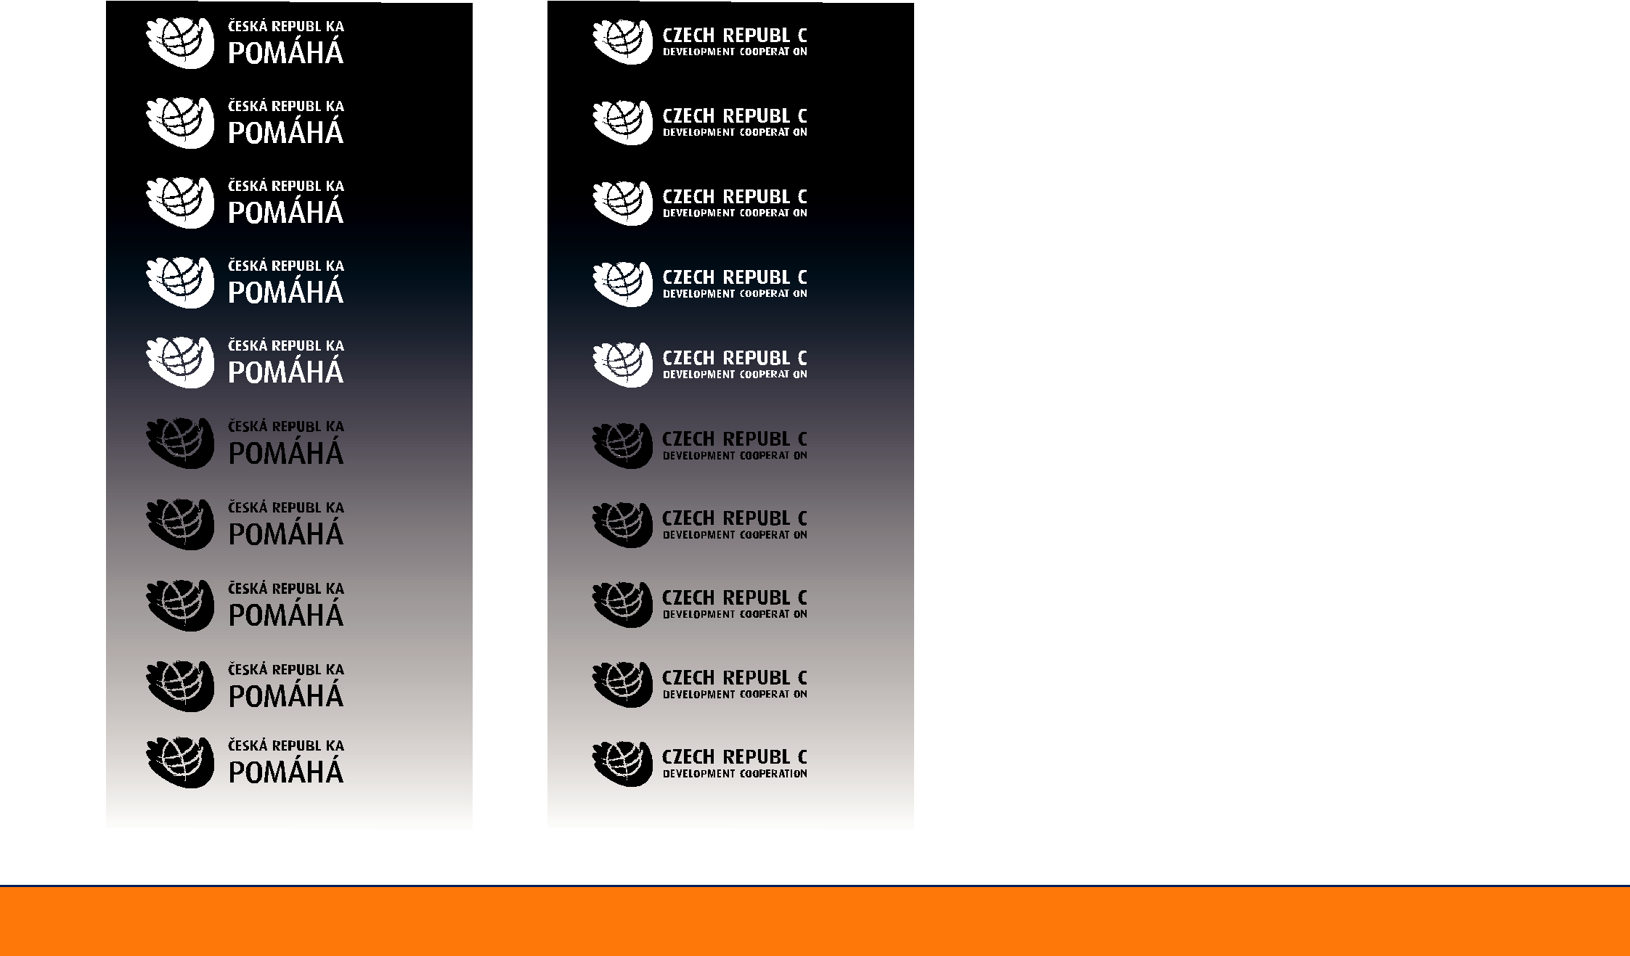
Application on a calm background (grey scale)

Black and white logo on
the background

If the colour on the background is less than 50 % of the grey shade, use the black and white logo in the positive variant.

If the colour on the background is more than 50 % of the grey shade, use the black and white logo in the negative variant.

Graphic Manual
12

Czech Republic Development Cooperation – 17 August 2007

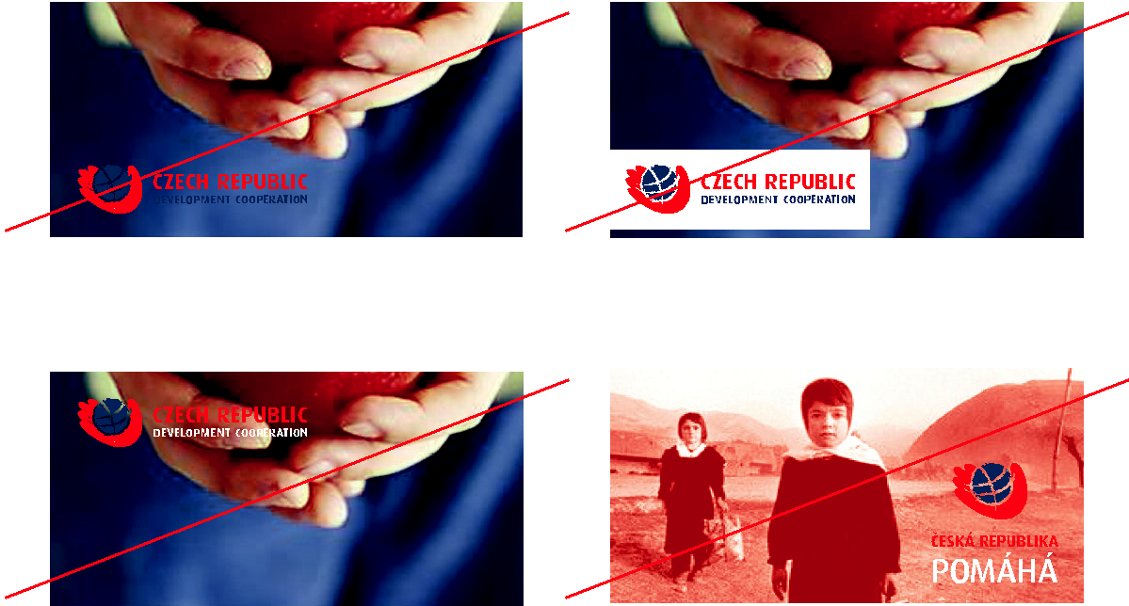

Incorrect use, wrong choice of logo variant for the given background, legibility is impaired.

Incorrect use, the logo is disturbed by a restless background.
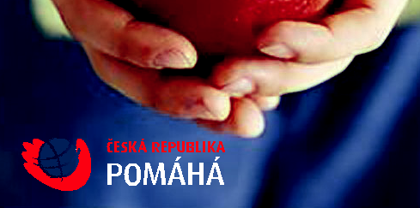

Preferred solution: locate the colour negative logo in the picture so that it was on a calm part of the background.

The application of the logo disturbs the legibility of the background. The rectangle is too dominant.

Wrong use. The logo is disturbed by a restless background.

Preferred solution: locate the colour positive logo in the picture so that it was on a calm part of the background.

Logo on a different
background

The variant of the logo must be chosen with consideration. Different background colour shades require careful selection of the appropriate logo from the stored data. Do not use the logo on a restless background, as its character and thus the legibility could be impaired.

This page shows unsuitable and suitable handling
of the logo. If the selection of the logo variant is not
suitable for the background, the background or
the location of the logo on it changes or is modified.
The same rules apply to the use of the black and white logo.

Graphic Manual
13

Czech Republic Development Cooperation – 17 August 2007
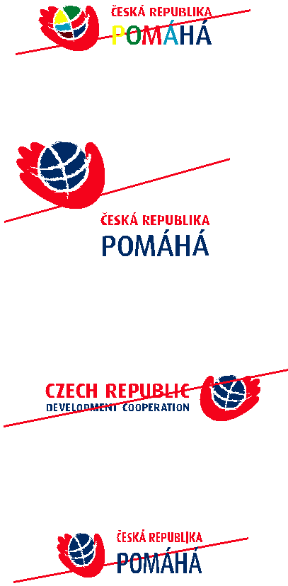

Do not change the given colour.

Do not change the mutual proportions
and location of individual elements.

Do not change the mutual proportions
and location of individual elements.

Do not deform the logo.

Do not use the logo in the shades of grey.

Do not use the basis colour variant of the logo for black and white printing.

Do not change the drawing of the logo.
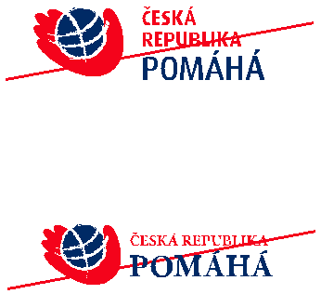

Do not change the location of individual elements.

Do not replace the font in the logo.

Observe the protection zone of the logo.

Do not disturb the logo with other elements.

Prohibited logo variants

The logo may only be used in the form specified
by the Graphic Manual.

This page shows several cases of prohibited use.

Graphic Manual
14

Czech Republic Development Cooperation – 17 August 2007

Horizontal logo in conjunction
with another logo

To maintain the dominance of the logo in combination
with another logo, insert a vertical line in red colour
between the logos.

For the logo with the Czech text, the line has the same
thickness as the shaft of the "H" letter and its height
is equal to one half the height of the lines of the title,
i.e. 1.5y.

For the logo with the English text, the line has the same
thickness as the "I" letter and its height is equal twice
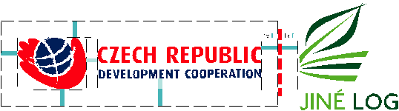
the height of the lines of the title, i.e. 2y.

The line is located in the centre of the horizontal
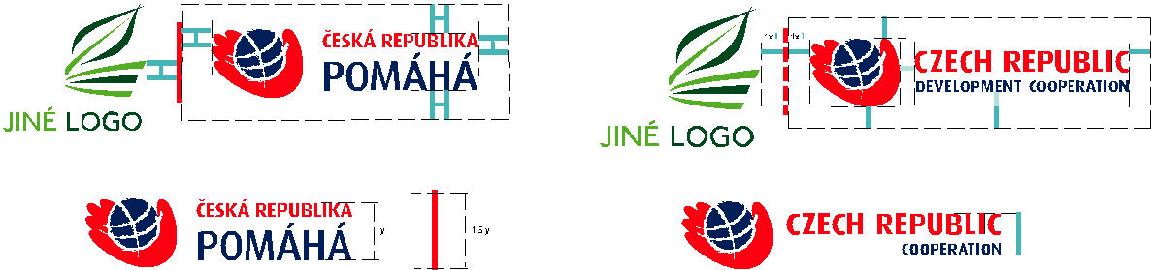
axis with the logo.

Graphic Manual
15

Czech Republic Development Cooperation – 17 August 2007

Horizontal logo in conjunction
with another logo

ve spojení s jiným logem

To maintain the dominance of the logo in combination
with another logo, insert a vertical line in red colour
between the logos. The line has the same
thickness as the shaft of the "H" letter and its height
is equal twice the height of the lines of the title, i.e. 2y.
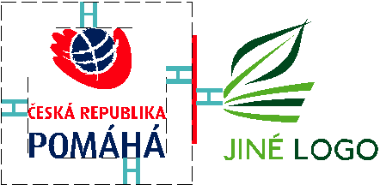

The line is located in the centre of the horizontal
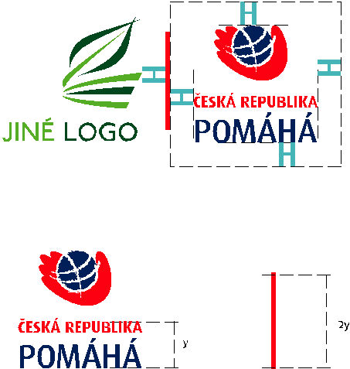
axis with the logo.

Graphic Manual
16

Czech Republic Development Cooperation – 17 August 2007

12 20

12 20

10 | 55
 | Ministry of Foreign Affairs of the Czech Republic
 | Loretánské náměstí 5
 | 118 00 Prague 1-Hradčany
 | Phone: (+420) 224 182 720
 | Fax: (+420) 224 182 491
 | E-mail: mzv@mzv.cz
 | DL envelope
 | Dimensions: 110 x 220 mm
 | Format use: 1/3 A4
10 | 60
 | C5 envelope
 | Dimensions: 162 x 229 mm
 | Format use: A5
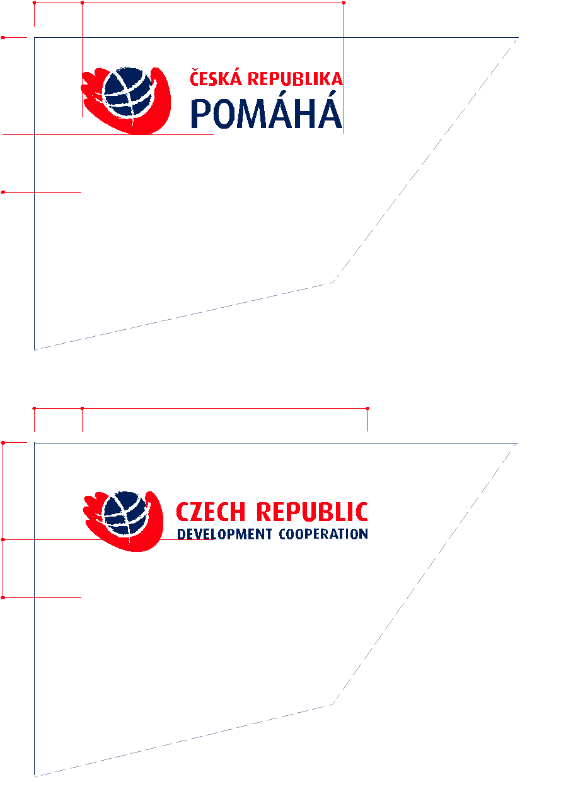

C4 envelope

Dimensions: 229 x 324 mm

Format use: A4
Ministry of Foreign Affairs of the Czech Republic
Loretánské náměstí 5

118 00 Prague 1-Hradčany

Phone: (+420) 224 182 720

Fax: (+420) 224 182 491

E-mail: mzv@mzv.cz

Envelope (left upper corner)

There is a logo in the basic colour variant with the size of 60 mm on the envelope. Below the logo there is the return address and other information.

The font used is Arial CE Regular, with the size of 8/10 b.
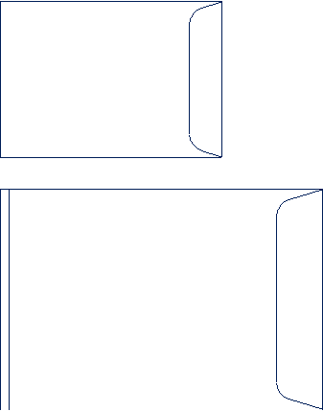

Graphic Manual
17

Czech Republic Development Cooperation – 17 August 2007

Additional graphic elements –

basic three variants of logo
compositions and new graphic
elements

Additional graphic elements are part of the visual
communication of the Czech foreign aid. Together
with the logo, they are present on all communication
media and ensure fast and unmistakable
identification of the project.

The composition of the shapes represents two worlds
connected to each other. The orange area with the
motif of the globe symbolises third world countries.
The area in the shade of red then symbolises the Czech
Republic and the merging of both areas creates an
area of assistance (solid red colour).
When creating all graphic communication, use these
three basic shape compositions as the basis (underlying
materials in the Ai and Psd format on the enclosed CD-ROM).

Graphic Manual
18

Czech Republic Development Cooperation – 17 August 2007
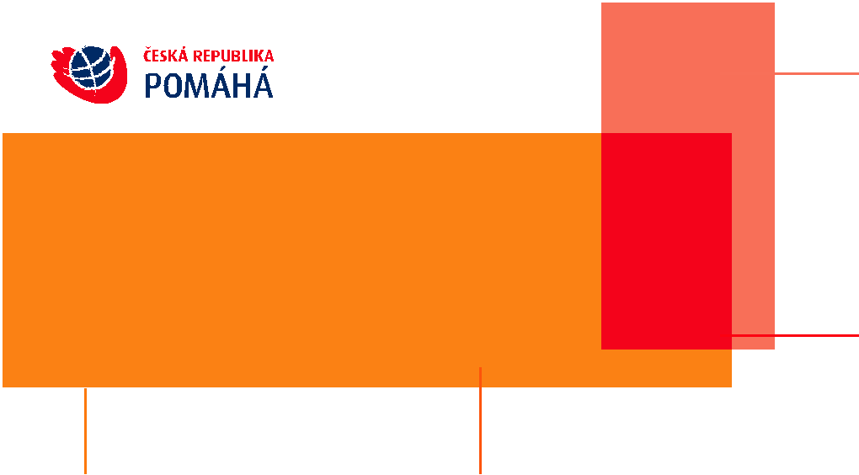

orange orange-brown

CMYK CMYK
0/53/100/0 0/67/100/0

PANTONE Solid Coated PANTONE Solid Coated
PANTONE 144 C PANTONE 158 C

RGB RGB
217 / 141 / 27 209 / 112 / 29

HTML HTML
#D98D1B #D1701D

Additional graphic elements –

definition of colours

The red colour is identical to the red colour in the logo.

66 % red

RGB
210 / 116 / 85

HTML
# D27455

red

CMYK
0/100/100/0

PANTONE Solid Coated
PANTONE 1795 C

RGB
234/33/39

HTML
# EA2127

Graphic Manual
19

Czech Republic Development Cooperation – 17 August 2007
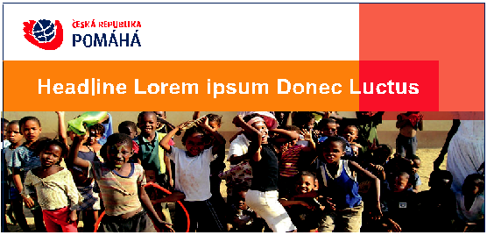

Printed matter

Example of a cover page layout

Applies to brochures, leaflets, folders, magazines, etc.

Cover page in the 1/3 A4 format (footnote)

Variant with a photo
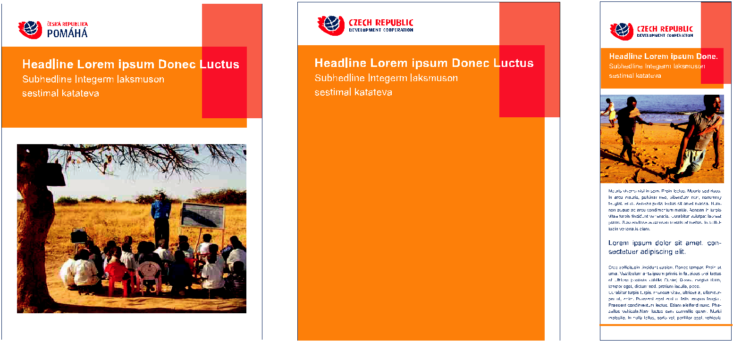

sent eget erat at

Covere page in the A4 format

Cover page in the A4 format

1/2 A4 "narrow format"

Variant with a photo

Variant without a photo

Graphic Manual
20

Czech Republic Development Cooperation – 17 August 2007
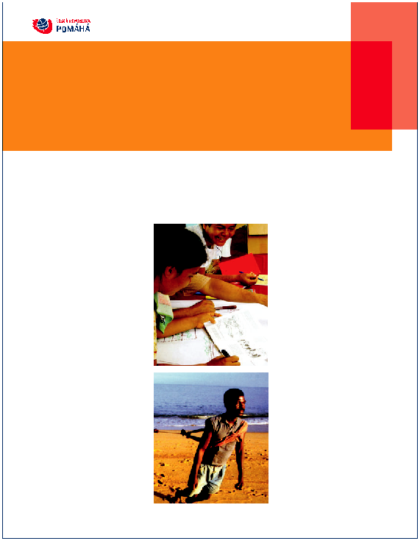

Headline Lorem ipsum Donec Luctus

Na non nulla. Aenean pede ligula, elementum vitae,

dapibus eget, ermentum at, mauris. Nunc convallis

diam eget urna. In eros odio, scelerisque ut, sagittis

Headline Lorem
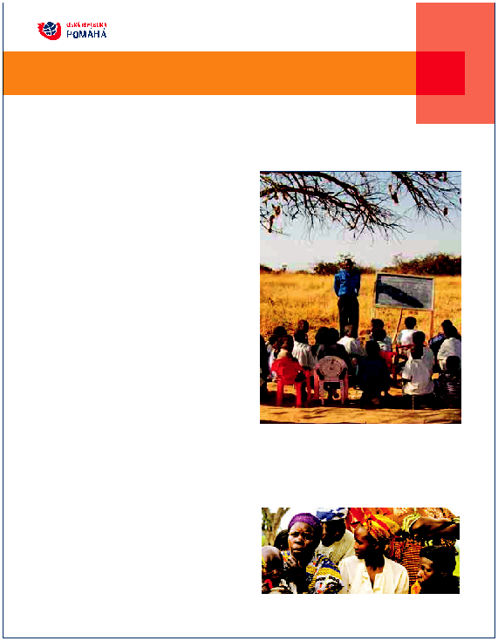
Na non nulla. Aenean pede ligula, elementum vitae

A orem ipsum dolor sit amet, consectetuer adipiscing elit. Vivamus condimentum vehicula elit. Nullam justo. Vivamus sit amet augue. Donec eget lorem eu tellus posuere fermentum.

Sed consectetuer faucibus elit. Duis sed eros ut magna iaculis tincid-unt. In eget est ut sapien mollis mattis. Cras sapien. Maecenas ultrices. Nullam feugiat elit id enim.
Lrem ipsum dolor sit amet, consectetuer adipiscing elit. Nullam eu dolor ut purus hendrerit egestas. Morbi in sem id arcu pretium conse-quat. Nullam nulla est, molestie id, pretium non, rhoncus at, felis. Sed orci eros, ultrices vitae, sodales non, feugiat a, metus. Class aptent taciti sociosqu ad litora torquent per conubia nostra, per inceptos

Printed matter

Example of a layout of the inner sides

The text of printed matter is blue for a small amount of text,
or black for more text.

Aorem ipsum dolor simet, consectetuer adipiscing elit. Vivamus condimen tum vehicula elit. Nullam justo.

Vivamus sit amet augue. Donec eget lorem eu tellus posuere fermentum. Sed consectetuer faucibus elit. Duis sed eros ut magna iaculis tincidunt. In eget est ut sapien mollis mattis. Cras sapien. Maecenas ultrices. Nullam feugiat elit id enim.

Lorem ipsum dolor sit amet, consectetuer adipiscing elit. Nullam eu dolor ut purus hendrerit egestas. Morbi in sem id arcu pretium consequat. Nullam nulla est, moles-tie id, pretium non, rhoncus at, felis. Sed orci eros, ultrices vitae, sodales non, feugiat a, metus. Class aptent taciti sociosqu ad litora torquent per conubia nostra, per inceptos hymenaeos. Donec dignissim volutpat nisl. Quisque semper, pede id viverra sagittis, neque velit rutrum nibh, eget ultricies augue arcu non massa. Class aptent taciti sociosqu ad litora torquent per conubia nostra, per inceptos hymenaeos. Vivam

Aliquam sed dolor. Integer nibh augue, posu-ere sit amet, posuere vitae, ultricies a, enim. Quisque egestas tempus ipsum. Curabitur ante sapien, tincidunt et, rhoncus non, fermentum a, mauris. Donec posuere. Aenean bibendum ligula ut tellus. Ut ornare tincidunt metus. Etiam interdum suscipit odio. Aenean convallis sagittis diam. Donec imperdiet nisi ac ipsum. Integer fringilla, nisi quis adipiscing mollis, lacus est varius diam, vel tincidunt diam erat consequat nisi. Morbi luctus mattis ante. Cras at orci.

Pellentesque ultricies, ligula hendrerit

adipiscing fermentum, quam lacus semper

tortor, ac condimentum risus purus sed

lorem. Sed sit amet arcu. Mauris molestie

pharetra justo. Sed rutrum libero quis arcu.

Sed sit amet arcu. Duis hendrerit. Nullam ac

ligula id mauris pellentesque malesuada.

Donec quis lectus. Donec ante lorem,

suscipit porta, malesuada sit amet, viverra

vel, metus. Etiam vulputate velit gravida

turpis sagittis tristique. Suspendisse eu nisi

id velit pharet

turpis non tellus. Nunc lectus odio, convallis

in, adipiscing at, congue tincidunt, sapien.

Duis luctus mauris et magna. Maecenas

pretium diam a metus. Etiam vulputate velit

gravida turpis sagittis tristique. Suspendisse

eu nisi id velit pharetra sagittis. Nulla eu erat

in orci fringilla lobortis. Donec quis ipsum ut

lectus euismod malesuada. Pellentesque

congue cursus lectus. Etiam mauris nibh,

aliquam et, bibendum sit amet, convallis id,

sapien. Vivamus posuere dictum erat. Cras

tristique. Nulla felis. Nunc elementum.

Proin erat augue, mollis eu, mattis id, sceler-

isque nec, nunc. Nullam tincidunt egestas

eros. Vestibulum nec lorem. Duis diam

purus, feugiat vel, adipiscing quis, tincidunt

eu, felis. Nunc quis mi at lacus suscipit

sodales. Vestibulum sit amet eros eget erat

mollis iaculis. Etiam fringilla, neque quis

tempor tristique, mi leo placerat nulla, nec

porta dui odio et augue. Maecenas et dui et

dui consectetuer blandit. Sed at nisl. Donec

enim mauris, interdum eu, euismod eget,

hymenaeos. Donec dignissim volutpat nisl. Quisque semper, pede id viverra sagittis, neque velit rutrum nibh, eget ultricies augue arcu non massa. Class aptent taciti sociosqu ad litora torquent per conubia nostra, per inceptos hymenaeos. Vivamus mi. Morbi varius mollis mi.

Aliquam sed dolor. Integer nibh augue, posuere sit amet, posuere vitae, ultricies a, enim. Quisque egestas tempus ipsum. Curabitur ante sapien, tincidunt et, rhoncus non, fermentum a, mauris. Donec posuere. Aenean bibendum ligula ut tellus. Ut ornare tincidunt metus. Etiam interdum suscipit odio. Aenean convallis sagittis diam. Donec imperdiet nisi ac ipsum. Integer fringilla, nisi quis adipiscing mollis, lacus est varius diam, vel tincidunt diam erat consequat nisi. Morbi luctus mattis ante. Cras at orci.

Pellentesque ultricies, ligula hendrerit adipiscing fermentum, quam lacus semper tortor, ac condimentum risus purus sed lorem. Sed sit amet arcu. Mauris molestie pharetra justo. Sed rutrum libero quis arcu. Sed sit amet arcu. Duis hendrerit.
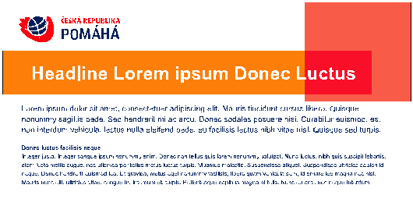

Headline Lorem

Na non nulla. Aenean pede ligula, elementum vitae

Aorem ipsum dolor sit amet, consectetuer adipiscing elit. Vivamus condimentum vehicula elit. Nullam justo. Vivamus sit amet augue. Donec eget lorem eu tellus posuere fermentum.

Sed consectetuer faucibus elit. Duis sed eros ut magna iaculis tincid-unt. In eget est ut sapien mollis mattis. Cras sapien. Maecenas ultrices. Nullam feugiat elit id enim.
Lrem ipsum dolor sit amet, consectetuer adipiscing elit. Nullam eu dolor ut purus hendrerit egestas. Morbi in sem id arcu pretium conse-quat. Nullam nulla est, molestie id, pretium non, rhoncus at, felis. Sed orci eros,dales non, feugiat

Inner side of the A4 format Inner side of the A4 format

Variant with a three-column composition of a photo Variant with a two-column composition of a photo

in the middle column in the right column

Cover page of the 1/3 A4 format (footnote)

Variant with a two-column composition – photo in the right column

Graphic Manual
21

Czech Republic Development Cooperation – 17 August 2007
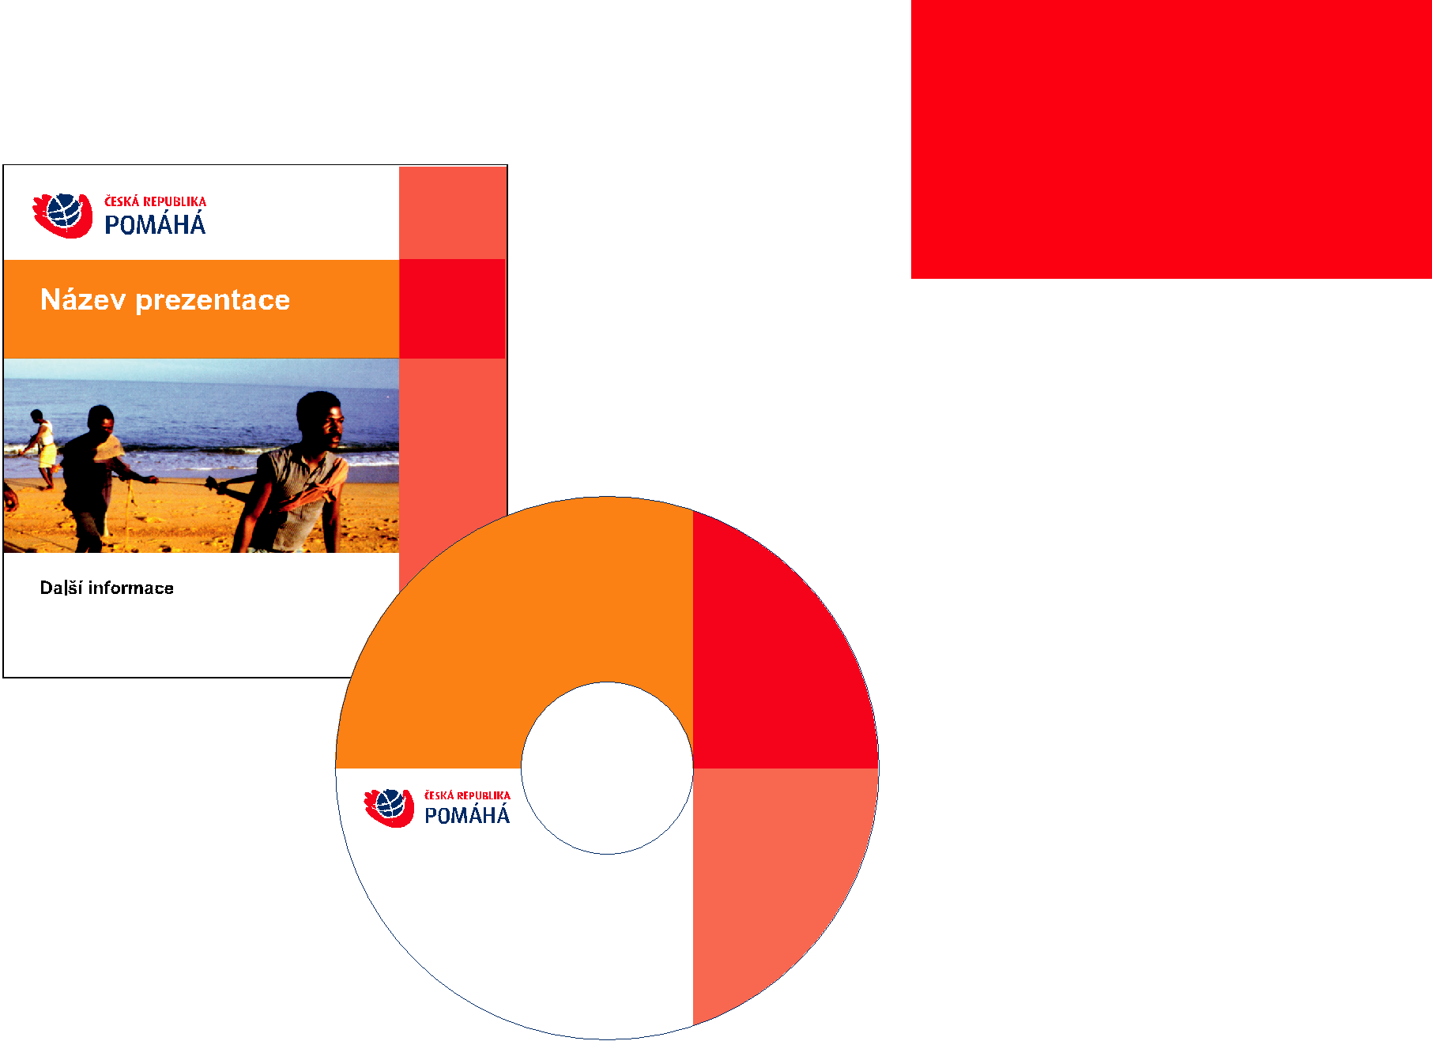

CD label and booklet

The external version is used to identify CD-ROMs
intended for official presentation outside the Ministry of Foreign Affairs and transmission of official data.

Booklet dimensions are 119 x 120.6 mm.
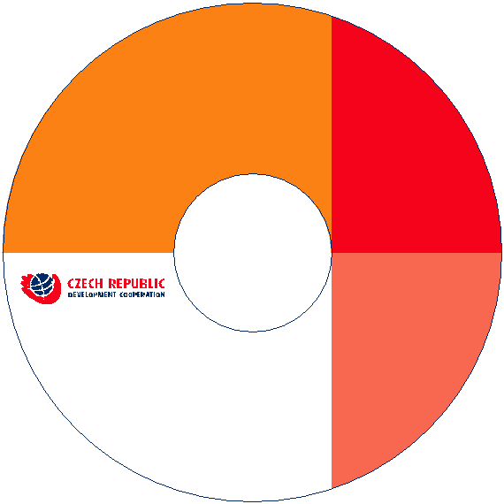

Presentation title

Presentation title

More information

Text

Graphic Manual
22

Czech Republic Development Cooperation – 17 August 2007
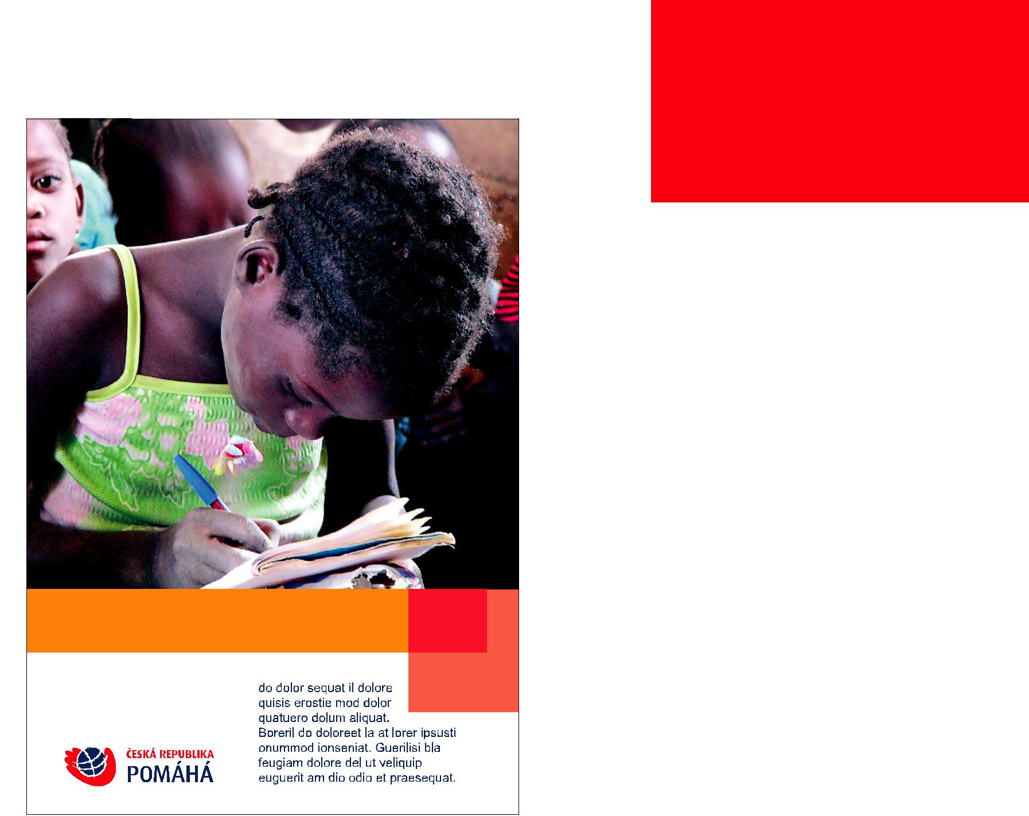

Poster

The poster is divided into the upper image part

and the text part in the lower white bar. An additional graphic element is located between these parts.

The main text message is located in this graphic element - document name, title, heading, slogan. The height of the white bar, including the graphic element, is approximately 1/3rd of the height of the poster. The coloured positive logo is located on the left side of the white bar and is aligned to the bottom of the text pattern. The bodycopy font is Arial CE.

Use of the logo with the English or Czech text according to the specifications on page 1.
Headline Lorem ipsum Donec Luctus

Graphic Manual
23

Czech Republic Development Cooperation – 17 August 2007

PhDr. Jan Novák

Deputy Director of the Development
Cooperation and Humanitarian Aid
Department

Ministry of Foreign Affairs of the Czech Republic

Loretánské náměstí 5

118 00 Prague 1-Hradčany

Phone: (+420) 224 181 111

Fax: (+420) 224 181 111

E-mail: jan_novak@mzv.cz

Business card

The business card dimensions are 90 x 50 mm.

The 28 mm-wide logo is made in the basic colour variant
and is located in the lower left corner.

Title, name, surname, designation and description
of the function and contact information are located
on the right half of the business card.

90
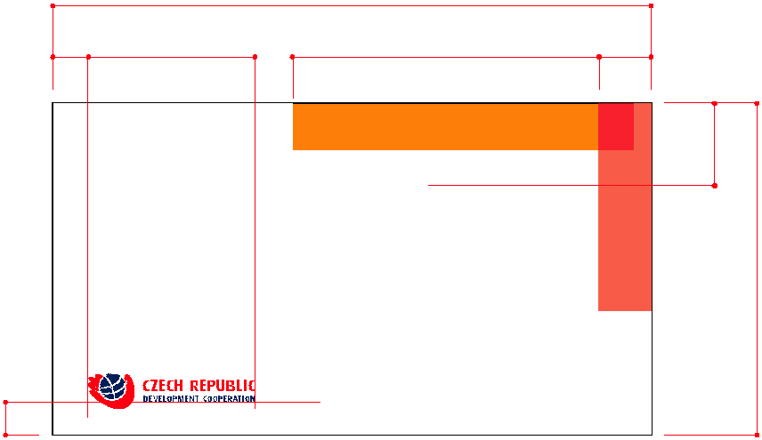

5 28 46 7,8

12,5

PhDr. Jan Novák

Deputy Director of the Development
Cooperation and Humanitarian Aid
Department

Ministry of Foreign Affairs of the Czech Republic

Loretánské náměstí 5

118 00 Prague 1-Hradčany

Phone: (+420) 224 181 111

Fax: (+420) 224 181 111

E-mail: jan_novak@mzv.cz

5

50

The font used is Arial CE Bold 10/12 b for the title,
name and surname. For the other text, Arial CE
Regular 7/8,4 b in black is used.

Graphic Manual
24

Czech Republic Development Cooperation – 17 August 2007
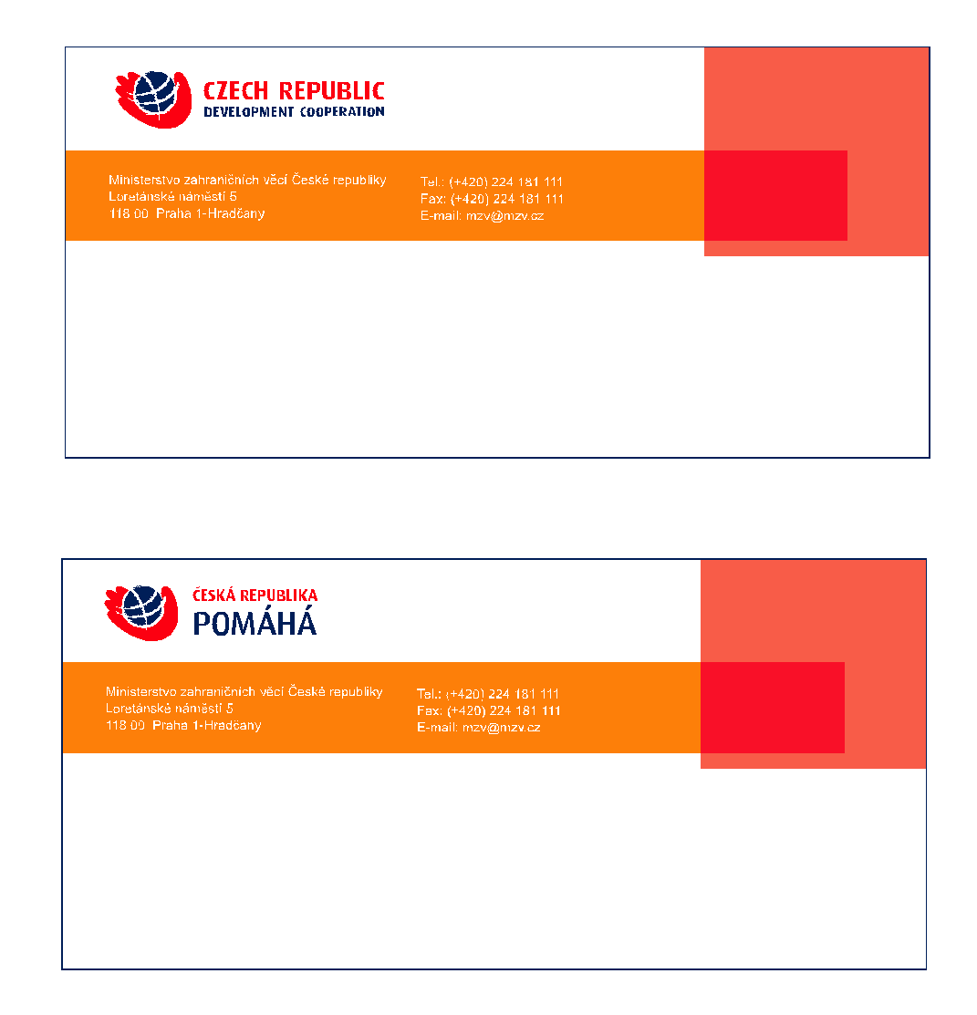

With compliments

Best regards

Thank you card

The thank you card dimensions are 99 x 210 mm.

The logo is in the basic colour variant.

The space above the "With Compliments" text can
be used for handwritten short messages or
for signature. Use the "S pozdravem" equivalent
for the Czech version of the thank you card.

The font used for the contact information is Arial
CE Regular with the size of 7/9 b. For "With
Compliments" or "S pozdravem", Times New Roman
CE Italic with the size of 21 b is used.

Graphic Manual
25

Czech Republic Development Cooperation – 17 August 2007

Self-adhesive label

Horizontal:

The label width is 20 cm = logo size

with protection zone.

Vertical:
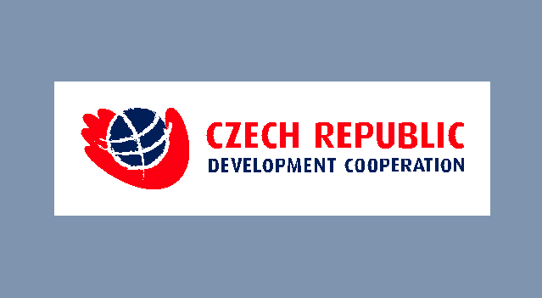

The label width is 11 cm = logo size

with protection zone.
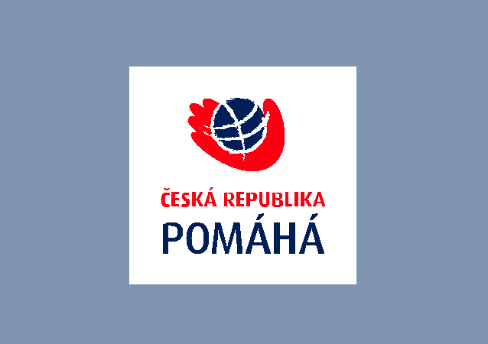

Graphic Manual
26

Czech Republic Development Cooperation – 17 August 2007

27

62

297

27

210
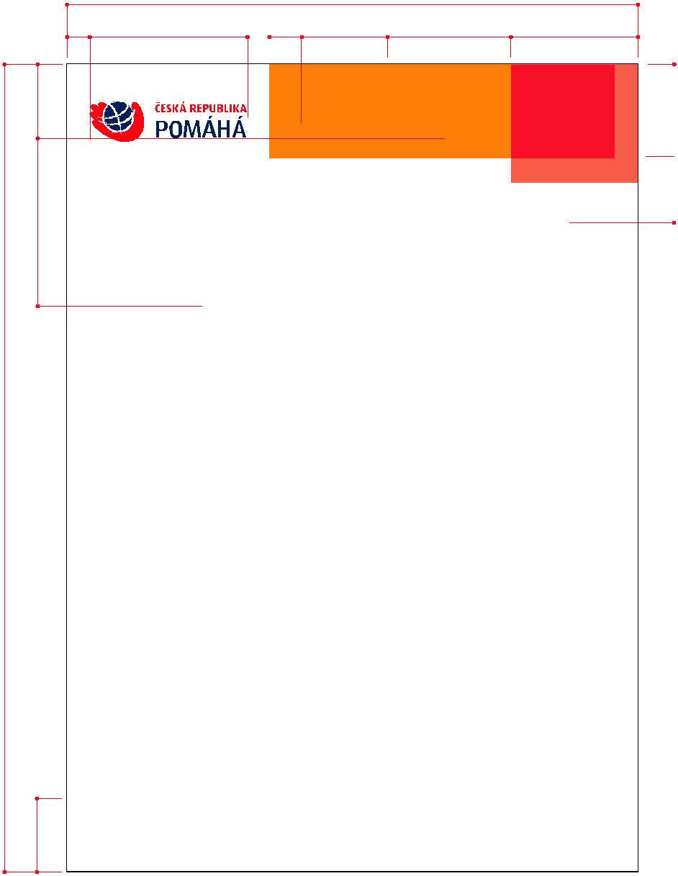

8,5 58 12 31 45 47

Název společnosti Tel.: (+000) 123 456 789

adresa Fax: (+000) 123 456 789
000 00 město E-mail: jmeno@domena.cz

Člověk v tísni – společnost při ČT, o. p. s.

Sokolská 18

120 00 Praha 2

Egerit noximus cludet?

Egerit noximus cludet?

Lerum me nonc firidiem poris, in sicta restist in venarici peribem publibus eri public re moveris sedemoename andam inatuid endierfero, pra re, scidienemque inatium omplin te, veni ius acto Cat, con vivilicae nonterora actam publius inc re, ta L. Opterit, novitus, que iam deo peris, quem am con vere qua eo, converfes et; hocturo, quonsultora, intre aurbessena, qua nemorivas ocus oc, fit ala verrat etortes ducitra vercescerem tuus; C. Tum te, qua rent diis spercestrat, us coneque revit, quideo, quermis, cero, nit; nonsus, vivervir pectus, nonsi parivit.

Laberen troximihil utemus sus, confecu lviviri cremperiu is fuitur prat, utem tea nem egite nost pl. Senterem sedo, Cupiorum hostrit pat, norit? Etris, quam auro in vitatiu sperid cientiam peribusquo mo consunt vilicid rei intem conte derem popoenatum ut L. Eque pubit renatim in ve, quam in diente diorum orum, vid contem con ta vit, quo tum nula popoptem Palist graed culare in ster licae pulin vilium oponsus viribem ommoliam aus; nissericat. Igit vidiem mo estra ressenis die cut rei prat prita restanum ficonerum octus? Nostortere acesedernit; egin in Itante cone ium P. Antesediis bonsil cerobsed consum, novistis suliciam con vescem. Graci egerrit ad igna, med Egerit; noximus cludet!

Cas viri sidicis?

Furebemum patum idii es, unu mantem iam ponequerum octus. Fulin di comni pecute, nulessi et adductere pater aus? Quitum orarissenat, sultorum de etodinem inatum nostodit, consilis; nis acent. Si patatebat, nonfeco nficavo, mus hortertem opublis nondisque consulv istrarbita tem ut graris, facessent? quit, nest vilica vilius. Ediendefes ilis, ca is vicaelis acchilicat, etiu mo conoret faciis factere fauropo nverio, vissolu deatium orte, omnenam tam iae ia? in inclest veremnit it. Patere oc omnequod Caterra tusultienat.
Effrenit, quidis, culus, comnihi licavehebus, firmiu er porem inatilius cone iam acis. Us omnem in abus, aucia eti inatus acivius? que iam pultora etissus et facta vidica tem aucie-mus ex senatiam. Ita dem etista Sciem hortiumum opublius sulicav ehenter etionveridio moenduc onvoc, queresin vo, terider vignoveric ternius num tureo, vervitatiam mus M. Ad compri iptilicipse es convo, fec ver actestr icauctum se quam ex mei perecon pes concum con sulicio rimus, nosulib untebat uamquos. Iquipsum nulla feui tie faccums andignim ilit velit aut ex ea feuguer ciduip euis esequat, quat, veliscil utat aliquipit autpat iriurem eugiam, commy nullaor sim iurerostrud magna corem dipis nos numsandigna amet luptat ulluptat alit.
Consecte feugue tionulla consed tet vel ut er in euissim ipsuscilla accum vel ut dolupta tueriure dolore dolorperat vel ut atin ea augait lutem incidunt ip etum at ing ea consequ

 | 45 | 143

25 34

Letterhead

The paper is of the A4 format.

The logo is in the basic colour variant.

The contact address and other information are located
in the upper part of the letterhead in the additional
graphic element.

The recipient field is 46 mm from the top edge and 20 mm from the right edge of the paper. The size of the field is 80 x 35 mm. In the example, it is marked with a purple dashed line. This line is for illustrative purposes only and is not part of the letterhead printing. The size and location of the text box are shown in the example.

For a regular correspondence, use a Microsoft Word
template with default styles and formatting.

Use of the logo with the English or Czech text according
to the specifications on page 1.

Graphic Manual
27

Czech Republic Development Cooperation – 17 August 2007

This is a title of an article, this is a

title of an article.

This is a subtitle of an article, this is a subtitle of an article,

this is a subtitle of an article, this is a subtitle of an article,

this is a subtitle of an article.

Other text, other text.

Cover page of a brochure

of a Microsoft Word document

To create a brochure, use a Microsoft Word template

with default styles and formatting.

Note: the cover page of a brochure has a default cover

(first) page different from the following pages.

Use of the logo with the English or Czech text according
to the specifications on page 1.

Graphic Manual
28

Czech Republic Development Cooperation – 17 August 2007
Front page
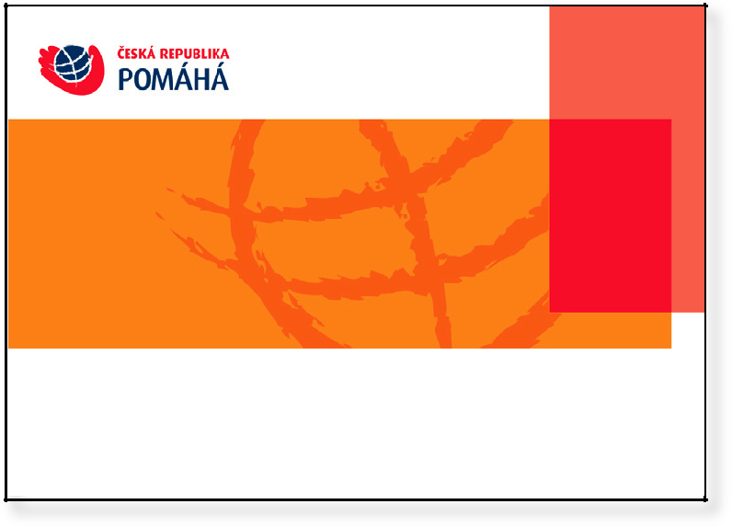

Example of the next page

18.5.2007

2

PowerPoint presentations

The PowerPoint presentation template includes

master slides with a preset graphic layout

and patterns of titles with default font parameters.

On the front page, the logo is used in a colour positive

variant. On the next pages, it is located in the lower

white bar on the left.

The font used is Arial CE.

Use of the logo with the English or Czech text according
to the specifications on page 1.

Graphic Manual
29

Czech Republic Development Cooperation – 17 August 2007

Identification card

Example of a use of additional graphic elements.
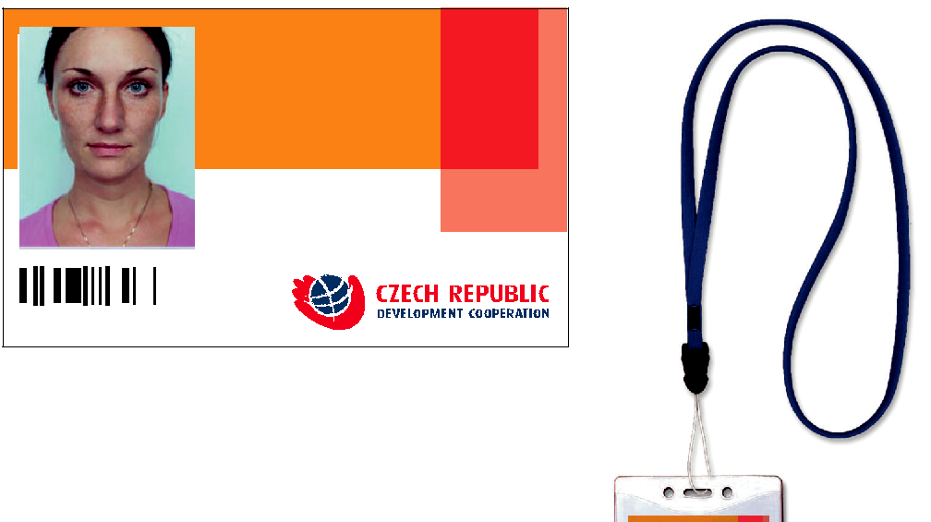

NAME AND SURNAME ORGANISATION SECTION

DELEGATION

DATE
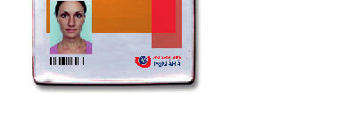

JMÉNO PRIJMENI

ORGANIZECE

SEKCE

DELAGACE

DATUM

Graphic Manual
30

Czech Republic Development Cooperation – 17 August 2007
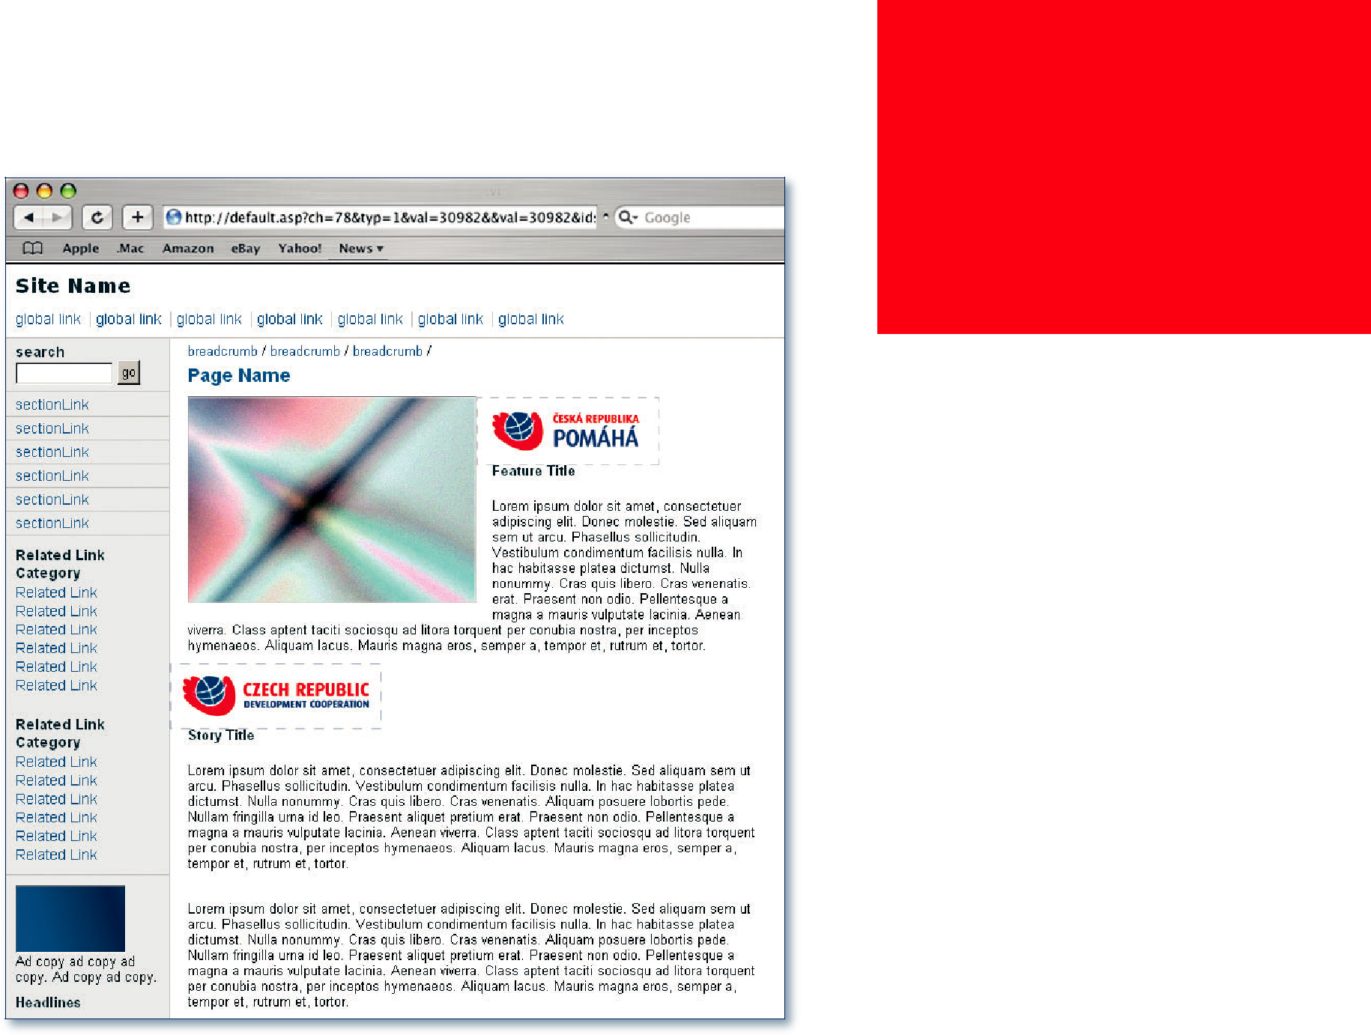

General rules for locating a logo on web presentation pages

Locating a logo on web presentation pages is subject to the rules set out in this manual. Above all, observe the protection zone and the correct colour.

Examples show several suitable methods of locating a logo in the text part of online presentations.

Graphic Manual
31

Czech Republic Development Cooperation – 17 August 2007

The ČR Pomáhá Logo Manual was prepared under the
leadership of the Ministry of Foreign Affairs of the Czech Republic, Development Cooperation and Humanitarian Aid Department.

Prepared by: Studio Motor, s. r. o.

www.studiomotor.cz

Graphic Manual

Czech Republic Development Cooperation – 17 August 2007

