CHALLENGE FUND
CZECH SOLUTIONS FOR SUSTAINABLE DEVELOPMENT GOALS
Ref Nr: UNDP-IRH-201909-CFP-06
Application form
The application should be sent to procurement.irh@undp.org by October 31, 2019, Istanbul Time, (GMT +3)
An application will be accepted only if it:
- is submitted on the correct form, completed in full and dated;
- is signed by the person authorized to enter into legally binding commitments on behalf of the applicant organization;
- presents a budget in conformity with the call for proposal;
- meets the submission arrangements set out in the call for proposal;
- is submitted by the deadline.

PROJECT

Project Title:
Date:
please select Country of Implementation:

☐ bosnia and herzegovina
☐ Republic of moldova
☐ Georgia

Amount applied for:
Duration: [no more than 12 months]
Requested budget: [between usd 20,000 and usd 40,000]

applicant -CONTACT DETAILS

Name of applicant’s organization:
Legal registration number, country and year of registration:
Type of Entity:
Postal address:
E-mail:
Telephone:
Website of applicant’s organization:
Name of contact person:
E-mail:
Telephone:

The Applicant is kindly asked to inform the Czech-UNDP Partnership for SDGs about any contact details change during the implementation of the project via procurement.irh@undp.org.

EXECUTIVE SUMMARY OF THE PROJECT

Please summarize a project intervention, proposed innovative solution and the its expected results in targeted county.

Context, Problem analysis and beneficiaries

Please briefly elaborate on the current situation, challenge solution and local demands for a proposed solution; identify the project beneficiaries - the target group(s); describe proposed innovative solution and its relevance for the country/target group.

What is a degree of innovation - level of novelty of the proposed solution? Is the proposed solution new to the global industry or only to local market? Does the proposed solution bring a new idea, approach, product or service to a target group? Please state a potential for scale up and replication.

Please mark SDGs relevant to the proposed solution:

☐ 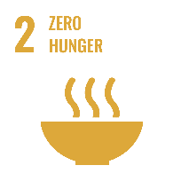 ☐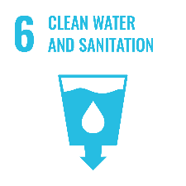 ☐ 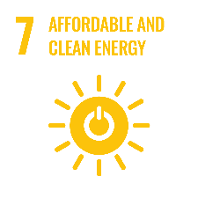 ☐ 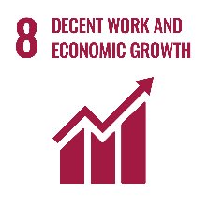

☐ 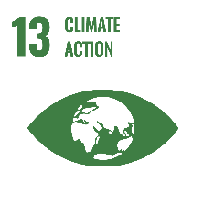 ☐ 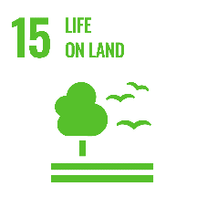 ☐

ESTIMATED Results

Please describe the estimated overall development impact and intervention logic of the proposed innovative solution including potential intervention scale-up and replication.

Activities

Please describe in detail the planned activities and timeline of proposed solution.

Budget

Applications must include a detailed estimated budget in balance using the EXCEL SHEET, in which the estimated costs are identified. These costs shall be given in USD. The estimated budget shall also be summarized below:

Requested Costs:
Co-funding:
Total costs:

The applicants provide co-funding of at least 20% of the total cost of the project. Co-funding can be in-kind. Co-funding above the minimum threshold is preferred and will be taken into account during evaluation.

Please describe value for money and cost effectiveness (the extent to which the proposed solution is expected to achieve its results at lower cost compared with alternatives).

Sustainability

Please provide information on the sustainability of the proposed actions. The following aspects of sustainability should be considered:

- financial sustainability (How will the activities be financed after the CFCS funding ends?)
- environmental sustainability (Will the proposed solution contribute to the quality of environment on a long-term basis?)
- social (How the proposed solution promotes wellbeing of people and understanding of their needs?)

local partner(s)

Local partner (name of the organization)
Legal registration number, country and year of registration:
Legal status:
Postal address:
E-mail:
Telephone:
Contact Person:
Website:

Project management

The Applicant should describe how the project will be managed, including the role of partners. The Applicant should provide a description of its relevant competences and previous experience as well as those of the key staff who will be involved in the project implementation (according to their profiles or CVs) as a proof of its capacity to implement project effectively.

PREVIOUS EXPERIENCE OF SIMILAR PROJECTS

Please present previous experience within the area of expertise

RISK MANAGEMENT

Please list the potential risks and your mitigation strategy.

Attachments to the application:

- CVs of Experts
- Budget (excel sheet)
- Extract from Public Registry
- The declaration of the partnership with local partner
- Any other relevant documents supporting the application

Acceptance of terms and conditions
By signing this form, the applicant accepts the following terms and conditions:
The applicant declares that he/she is bounded by the process and rules of the competition that have been highlighted in the Guidelines and shall accept the outcome of the process without any deviation or reservation.
The applicant shall bear all costs related to the preparation and submission of the proposal regardless of whether his/her proposal is selected or not. He/she accepts that the CFCS nor the UNDP will in no case be held responsible or liable for those costs regardless of the outcome of the process.
The applicant accepts that CFCS determines the level of responsiveness to a challenge fund window exclusively on the contents of the written application forms.
The applicant accepts that information relating to the examination, evaluation, and comparison of applications, and recommendation of contract award shall not be disclosed to you or any other person not officially concerned with such processes.

Signature: …………………………………………………
Name: ……………………………………………………….
Date: …………………………………………………….

